

**Team name : ChatTech**

**Project name : I-messenger**

By

**Mohit Mordiya**

**Yash Vachhani**

**Surbhi Rank**

**Submitted by**

**DUHacks 2.O**

**Dharamsinh Desai University**

**Project Profile**

|  |  |
| --- | --- |
| Project title | I – messenger |
| Team name | ChatTech |
| Team size | 3 |
| Operating system | Microsoft Windows 10 |
| Front end used | HTML, CSS, JavaScript & php |
| Back end used | MySql database |
| Submitted by | Mohit Moradiya  Yash Vachhani  Surbhi Rank |
| Submitted To | **DUHacks 2.O** |

**Table content**

|  |  |  |  |  |
| --- | --- | --- | --- | --- |
| **Sr. no** | **Description** | | | **Page No.** |
|  | | | | |
| **01** | **Introduction** | | | **1** |
|  | 1.1 | | Background | **2** |
|  | 1.2 | | Objective | **2** |
|  | 1.3 | | Purpose | **2** |
| **02** | **Requirement & system analysis** | | | **4** |
|  | 2.1 | | Problem definition | **5** |
|  | 2.2 | | Requirement specification | **5** |
|  | 2.3 | | Hardware & software requirement | **7** |
|  | 2.4 | | Preliminary Production Description | **8** |
|  | 2.5 | | Feasibility study | **11** |
| **03** | **SDLC** | | | **14** |
|  | 3.1 | | System development strategies | **15** |
|  | 3.2 | | Introduction of SDLC | **15** |
|  | 3.3 | | Phase of SDLC | **16** |
|  | 3.4 | | Application of SDLC method | **21** |
|  | 3.5 | | Limitation of SDLC | **22** |
|  | 3.6 | | Advantages of SDLC | **23** |
| **04** | **System Design** | | | **24** |
|  | 4.1 | Introduction | | **25** |
|  | 4.2 | Data dictionary | | **28** |
|  | 4.3 | Er – diagram | | **37** |
|  | 4.4 | Data flow diagram | | **40** |
| **05** | **Organization chart and screen design** | | | **50** |
|  | 5.1 | Organization chart | | **51** |
|  | 5.2 | Screen design | | **54** |
| **06** | **Testing & test cases** | | | **69** |
|  | 6.1 | | Introduction and objective | **70** |
|  | 6.2 | | Types of testing | **70** |
|  | 6.3 | | Level of testing | **77** |
|  | 6.4 | | Introduction of test cases and parameter | **78** |
|  | 6.5 | | Test cases | **79** |
| **07** | **Future enhancement** | | | **90** |
| **08** | **Bibliography** | | | **92** |

1. **Introduction**
2. **Introduction**
   1. **Background**
   2. **Objectives**
   3. **Purpose and scope**
3. **Introduction :**

I-messenger is a type of unique web application. I-messenger is an instant messaging web application. It provide

Project name : **i-messenger**

* 1. **Background:**

I-messenger is used to send message and exchange photos, upload video, images, audio and pdf. It is provide other facility like

* Generate text message pdf in particular user or all user.
* Create group and communicate multiple user.
* Show all user story and upload story.

The user can sign in first, then login and take functionalities of all the features of this web app

* 1. **Objective:**
* To communicate other user easily in anytime and anywhere.
* You can send information easily.
* You can search friends easily.
* Upload story easily.
* Show all user stories.
* Upload images, pdf, audio and video etc.
  1. **Purpose & scope :**

The system will be mainly design for small a social media in provide services users..

* You can represent your expression or event using story.
* It also use to change your profile image.
* This web application is support to sending data, or file like audio, video, pdf, images
* This web application is also generate pdf of user text message.
* This web application is easy to search in other user and send messages.

1. **Requirement and system analysis**

**2.Requirement and system analysis**

* 1. **Problem definition**
  2. **Requirement specification**
  3. **Hardware and software requirement**
  4. **Preliminary production description**
  5. **Feasibility study**

**2.1 Problem definition**

i-messenger is a one type of web application. This system is use to sending a data, to send a personal document, to create group and communicate multiple user and show all user story and upload your story. There are many problems in other system. Like high network speed, low response in browser, not generate pdf in text message.

* **Network speed**
  + Other web applications require high network speeds while these web applications can work easily even if they have low network.
  + This system is also work in smoothly in browser.
* **Performance**

Performance of other web apps is low in browsers when performance of these web applications is good in any browser.

* **Generate pdf to message**

You can generate pdf in important text message in particular user and all user

* **Story size is low**

Other application upload story only 30 sec or 1min. But this application is store 500Mb (0.5 GB) story.

**2.2 Requirement specification**

There are two type of requirement specification.

1. Functional requirement specification
2. Non – functional requirement specification

* **Functional requirement** **specification**
* **User**

You can sign and login this system whenever you authenticated person you can perform all operation like update profile, chatting etc.

* **Chat**

This feature can be used for chatting. Use to view messages sent by other users and to send messages to other users.

* **Story**

This feature can be used for story. You can represent your expression or event using story. You can easily upload your story and show all users story. This story size is allowed 500Mb.

* **Add user**

You can add many friends in our system. You can register in multiple accounts in this system.

* **Create Group**

This functionality is use to create group to join multiple user. Group admin is update group data, delete group, add other user, remove user.

* **Generate pdf**

This functionality is use to create pdf in text message to in particular message, all user and group message.

* **Show all uploaded and receiving file in full screen**

You can show all uploaded file in small screen preview and full screen preview and easily download a file.

* **Non – functional requirement specification**
* **Security**

This web application is provide high security.

* **Performance**

Performance of other web apps is low in browsers when performance of these web applications is good in any browser.

**2.3 Hardware & Software requirement**

Software and hardware needed for the development and implementation of our project. There are following hardware us required for this system.

1. 512 MB RAM
2. 32 GB Hard Disk
3. Printer(optional)
4. Power backup

There are following software is required for the system.

1. Mysql database
2. Web browser
3. Xampp server/ wamp server

**2.4 Preliminary Production Description**

In our project the preliminary work has been started and I gathered client’s requirements, now I am designing after that we are going to start design for project.

**HTML (Hyper Text Markup Language)**

 HTML stands for Hyper Text Markup Language. HTML is not only way to present information on the web, but it’s the glue that holds everything to gather. In addition to being a markup language for displaying text, images and multimedia, HTML provides instructions to web browsers in order to control how documents are viewed and how they relate to each other. For all its simplicity, HTML is a very powerful language.

* HTML stands for Hyper Text Markup Language.
* An HTML file is a text file containing small markup tags.
* The markup tags tell the web browser how to display to the page.
* An HTML file must have an HTM or HTML extension.
* An html file can be created using a simple text editor.

**PHP (Hypertext Pre-Processor)**

Php is a scripting language originally designed for producing dynamic web pages. It has evolved to include a command line interface capability and can be used in standalone graphical applications.

While PHP was originally created by **Rasmus Lerdorf** in **1995**, the main implementation of PHP is now produced by the PHP Group and serves as the defector standard for PHP as there is no formal specifications. PHP is free software released under the PHP license; however it is incompatible with the GNU general public license (GPL), due to restrictions on the uses of the term PHP.

PHP is a widely-used general-purpose scripting language that is especially suited for web development and can be embedded into HTML. PHP has grown from simple beginnings to a full-fledged object oriented language that can run both windows and UNIX/Linux platforms. The main advantages of using PHP over other platforms, such as Java or .net, are that it is smaller, much simpler to install, and more lightweight, needing only a fraction of the memory of the Java runtime of the .Net CLR. Science it is an open source language and we do not have to purpose it, it seemed best choice for the development of our project as we had to maintain a very low budget throughout out project.

**Feature of PHP**

The following features of PHP are

* Simplicity
* Portability
* Speed
* Open source
* Extensible
* XML and database support

**JavaScript**

Java script is a scripting language used to enable programmatic access to objects within other applications. It was developed by **Brendan Eich**.

It is primarily used in the form of client-side JavaScript for the development of dynamic website. Java script is a dialect of the ECMA script standard and is characterized as a dynamic, weakly typed, prototype-based language with first-class functions. Java script was influenced by many languages and was designed to look like java, but be easier for non-programmers to work with.

Java script, despite the name, is essentially unrelated to the java programming language even though the tow does have superficial similarities. Both languages use syntaxes influenced by that of C syntax, and java script copies many java names and naming conventions. The language’s name is the result of a co-marketing deal between Netscape and Sun, in exchange for Netscape building sun’s Java runtime with their then-dominant browser. The key design principles within Java Script are inherited from the self and scheme programming languages.

“JavaScript” is a trademark of sun microsystems. It was used under licences for technology invented and implemented by Netscape Communications and current entities such as the Mozilla Foundation.

**CSS (Cascading Style Sheet)**

Cascading Style Sheets (CSS) is a style sheet language used to describe the presentation (that is, the look and formatting) of a document written in a Markup language. It’s most common application is to style web pages written in HTML and XHTML, but the language can be applied to any kind of XML document, including SVG and XUL.

CSS is designed preliminary to enable the separation if document content (written in HTML or a similar markup language) from document presentation, including elements such as the colours, fonts and layout. This separation can improve content accessibility, provide more flexibility and control in the specification of presentation characteristics, enable multiple pages to share formatting, and reduce complexity and repetition in the structural content (such as by allowing for table less web design).

CSS can also allow the same markup page to be presented in different styles for different rendering methods, such as on-screen, in print, by voice (when read out by a speech-based browser or screen reader) and on braille-based, tactile devices.

**MySQL**

MySQL is a high-performance, multiuser relational database management system for database driven software applications. Designed around three fundamental principles-speed, stability and ease of use, and freely available under the GNU (General Public License). MySQL has been dubbed “the world’s most popular open-source database” by its parent company, MySQL AB.

Today, MySQL is available for a wide variety of platforms, including Linux, Mac OS and Windows.

**Features of MySQL**

The following features of MySQL are

* Speed
* Reliability
* Security
* Scalability and portability
* Ease of use
* Compliance with existing standards
* Wide application support

**2.5. Feasibility Study**

Feasibility study is a test of system proposal according to its workability, impact of the organization, ability to meet needs and effective use of the resources. Feasibility is the determination of whether or not a project is worth doing the process followed and making this determination is called feasibility analysis. This determines whether a project can and should be achieved. Once it has been determined that a project is feasible, the analyst can go ahead and prepare the project specification which finalizes project requirements.

Generally, feasibility analyses are undertaken within right time constraints and normally conclude in a written and oral feasibility report. The contents and recommendations of such a study will be used as a sound basis for deciding whether to proceed, postpone or cancel the project.

Thus, since the feasibility analysis may lead to the commitment of large resources, it becomes necessary that it should be conducted competently and that no fundamental errors of judgment are made.

1. **Technical feasibility**

A large part of determining resource has to do with assessing technical feasibility. It considers the technical requirements of the proposed project. The technical requirements are then compared to the technical capability of the organization.

The systems project is considered technically feasible if the internal technical capability is sufficient to support the project requirement.

The analyst must find out whether current technical resource can be upgraded or added to in a manner that fulfils the request under consideration. This is where the expertise of system analysts is beneficial, since using their own experience and their contact with vendors they will be able to answer the question of technical feasibility.

1. **Economic feasibility**

Economic analysis could also be referred to as cost/ benefit analysis. It is the most frequently used method for evaluating used method for evaluating the effectiveness of a new system. In economic analysis the procedure is to determine the benefit and savings that are expected from a candidate system and compare them with costs. If benefits outweigh costs, then the decision is made to design and implement the system. An entrepreneur must accurately weigh the cost versus benefits before taking an action.

1. **Operational feasibility**

Measure how much the proposed system solves the existing system problems. This project is surely operationally feasible because the proposed system (the project) is a good solution maker of the problem or specific solution will work in the existing system and create a good environment towards the user of our application. The project can cover the following activities

* The new system will be automatic because it will deal with a database.
* A complete design of the new project system.
* Will be interactive and user friendly.
* Will be easy to navigate and manipulate.
* The system will come up with updated information and register content.
* The system is user friendly and suitable especially for the user.
* Minimizing consumption of time and cost.

1. **SDLC**
2. **System Development Life Cycle**

**3.1. System development strategies**

**3.2. Introduction of SDLC**

**3.3. Phases of SDLC**

**3.4. Application of SDLC method**

**3.5. Limitation of SDLC**

**3.6. Advantages of SDLC method**

1. **SDLC**

* **System development strategies**
  + Computer information systems servers many different purposes, variety from the processing of business transactions for providing information needed to decide recurring issues, supporting senior officials with different strategy formulation, and linking office information and corporate data.
  + In some instances, the factors to be considered in information system projects, such as the most appropriate feature of computer or communication technology to be applied, the impact of a new system on the people in a compact, and the specific features the system should have can be determined in a sequential fashion.
  + These different situations are represented by three separate approaches to the development of computer information systems:
    - System Development Life Cycle Method (SDLC)
    - Structured Analysis Development Method (SADM) / Structured System Analysis and Design Method (SSADM)
    - System Prototype Method (SPM)
* **Introduction of SDLC**
* SDLC is known as “System Analysis Life Cycle”.
* System development, a process consisting of the two major step of system analysis and design, starts when management or sometimes systems development person realize that particular business system needs improvement.
* “The system development life cycle (SDLC) method is classically thought of as the set of activities that analysist, designers and users carry out to develop and implement an information system.”
* These section study each of the eight activities that make up the systems development life cycle.
* **Phases of SDLC**
* The systems development life cycle method consists of the following phases:

1. Preliminary investigation
2. Determination of system requirements
3. Design of system
4. Development of software
5. System testing
6. Implementation
7. Evaluation
8. Maintenance
9. **Preliminary investigation**

* When that request is made, the first system activity, the preliminary investigation, begins. This activity has three parts:

1. **Request clarification**

* Many request from employees and users in organizations are not clearly confirmed.
* Therefore, before any systems investigation can be considered, the project request must be study.
* To determine exactly what the designer wants.
* In either case, before any further steps can be taken, the project request must be clearly declared.

1. **Feasibility study**

* An important result of the preliminary investigation is the system requested is feasible (possible).
* There are three aspects in the feasibility study portion of the preliminary investigation:

1. **Technical feasibility**

Can the work for the project be done with current equipment (tools), existing software technology, and available human resources?

1. **Economic feasibility**

Are there sufficient benefits in creating the system to make the cost acceptable?

1. **Operational feasibility**

Will the system be used if it is developed and implemented?

The feasibility study is approved out by a small group of people (sometimes even one or two) who are familiar with information systems techniques, understand the part of the business or organization that will be involved or affected by the project, and are skilled in the system analysis and design process.

1. **Request approval**

Not all requested projects are wanted or feasible. Some organizations receives so many project requests from employees that only a few of them can be follow.

However, those projects that are both feasible and wanted should be put into a schedule. Many business organizations develop information system plans as carefully as they plan for new products, new manufacturing programs, or plant development.

1. **Determination of system requirement**

* At the heart of system analysis is a detailed understanding of all important facts of the business area under investigation.
* Analyst, working closely with employees and managers must study the business process to answer these key questions:

1. What is being done?
2. How is it being done?
3. How frequently does it occur?
4. How great is the level of transactions or decisions?
5. How well is the task being exist?
6. Does a problem exist?
7. If a problem exists, how serious is it?
8. If a problem exists, what is the original reason?

* To answer these questions, systems analysts talk to a variety of persons to gather details about the business process and their opinions of why things happen as they do and their ideas for changing the process.

As the details are gathered, the analyst study the requirements data to identify features the new system should have, including both the information the system should produces and operational features such as processing control, response times, and input and output methods.

1. **Design of system**

* A life cycle moves from analysis phase to design phase, in fact it is moving from conceptual features to physical features of life cycle.
* Analysis related with “what” where as design phase is more related with “how”.
* This phase defines futures system in terms of the system specifications, where common specification are
  + Output design
  + Input design
  + Procedures
  + Information flow
  + Files and database etc.
* The design of an information system produces the detail that state how a system will meet the requirements identified during system analysis.
* System specialist often refer to this stage as logical design, in difference to the process of developing program software, which is referred to as physical design.
* System analyst begin the design process by identifying reports and other outputs the system will produce.
* Designers are responsible for providing programmers with complete and Clearly outlined software specifications.

1. **Development of software**

* Software developers may install or modify and then install, purchased software or they may write new, custom – designed programs.
* The choice depends on the cost of each option, the time available to write software, and the availability of programmers.
* Programmers are also responsible for documenting the program, providing a clarification of how and why certain procedures are coded in specific ways.

1. **System testing**

* During systems testing, the system is used testing to ensure that the software does not fail, i.e., that it will run according to its specification and in the way users imagine.
* Special test data are input for processing, and the results study.
* In many organizations, testing is performed by persons other than those who wrote the original programs to ensure more complete and balanced testing and more consistent software.

1. **Implementation**

* Implementation is not at all creative process but it is verify difficult process to execute.
* It is because end user have to accept the newly implemented system and therefore human thought will have higher priority at this stage.

**Implementation includes:**

* Side preparations.
* Installations of new equipment.
* User’s training, seminars, meetings to increase user support.
* Use of new inputs and procedures

1. **Evaluation**

* Evaluation of the system is performed to identify its strength and weakness. The actual evaluation can occur along any of the following dimensions:

1. **Operational Evaluation**

Assessment (review) of the manner in which the system functions including simplicity of use, response time, correctness of information formats, overall consistency, and level of utilization.

1. **Organizational Impact**

Identification and capacity of benefits to the organization in such area as financial concern (cost, revenue and profit), operational efficiency, and competitive impact. Includes impact on internal and external information flows.

1. **User Manager Assessment**

Evaluation of the attributes of senior and user managers within the organization as well as end – users.

1. **Development Performance**

Evaluation of the development process in agreement with such standard as overall development methods and tools.

1. **Maintenance**

* Maintenance is necessary to reduce the errors in the system during its operations and to correct the system any variations in its working environment.
* In this phase changes are made in system by adding or deleting features to satisfy use needs.
* The importance is to continue to bring the new system to standard system.
* **Application of SDLC method**

System development life cycle is best method of developing a system under following conditions:

* Predictable information system requirements.
* Manageable as a project.
* Requires entry of data into files and databases.
* High transaction and processing volume.
* Requires validation of data input.
* Duration several departments.
* Long development timetable.
* Development of project as a team.
* **Limitation of SDLC**

Classical system development life cycle method has the following limitations:

* In SDLC interaction with the user is limited. The user interact with the system at the problem identification and feasibility study phases, after that they are predictable to use the system when it is implemented.
* The system analyst is consistently overloaded with the business and technical details of the system.
* The analytical tools of SDLC like system flow chart, program flow chart, are constructed more with physical feature of the system rather than logical features. Also, some tools are description and subjective instead of accurate and clear.
* Software development is a bottom-up approach, so that the entire package (system) can be seen only after it is fully completed, by which time becomes more difficult to make any correction.
* All system documentation is prepared at the end of the project.
* In short SDLC has required the structured system development approach.
* The structured methodology has overcome most of the disadvantage of classical SDLC method.
* What may be seen as a major problem for some, end-user does not see the solution until the system is almost complete.
* Documentation is expensive and time-consuming to create. It is also difficult to keep current. What may be current this month may not be the same this time next year.
* Users cannot easily review intermediate products and evaluate whether a particular product (e.g., data flow diagram) meets their business requirements.
* **Advantages of SDLC method**
* Formal review is created at the end of each stage allowing maximum management control.
* This approach creates great system documentation.
* This documentation ensures that system requirements can be suggestion back to stated business requirements.
* It produces many intermediate products that can be reviewed to see whether they meet the user’s needs and match to standards.
* These can be further worked on if they require data to be made, ensuring that the business gets exactly what it needs.

1. **System Design**

1. **System Design**
   1. **Introduction** 
      1. **Overview**
      2. **All from description**
   2. **Data dictionary**
      1. **Introduction**
      2. **Data dictionary**
   3. **ER – diagram** 
      1. **Introduction**
      2. **Component of ER diagram**
      3. **ER – diagram**
   4. **Data flow diagram**
      1. **Introduction**
      2. **Types of DFD**
      3. **Notation for DFD**
      4. **Rules for DFD**
      5. **All diagram**
2. **System Design** 
   1. **Introduction** 
      1. **Overview**

I-messenger is one type of web application. This system is use to sending a message in other user. The primary objective of this application is communicating other user. This application should be capable enough to store the more than 5000 user and also changes your profile and delete account. It will be having user friendly web application that will guide the user to easily communicating other user. In addition to this the application also supports feature to search other user and communicate by audio call. This web application is to be fully developed HTML, CSS, JavaScript and php.

* + 1. **All from description**

1. **Register form**

In registration is the first step of the web application. The following details are mandatory when you first register.

* User_name
* Full name
* Date of birth
* Gender
* Email
* About
* Profile image

1. **Login form**

In login forms is used to user login into the system. Here check out the user name and password is correct or not. Whenever username and password is correct at that time open the dashboard, otherwise generate an error message.

**Structure of the login form :**

* User name
* Password

1. **Forget password**

User is forgetting a username or password at that time you can verify username, email, birthdate and full name is valid at that time you can change a password

**Verify user data**

* Username
* Full name
* Birthdate
* Email id

**Change password**

* New password
* Confirm password

1. **Search other user**

After login the system at that opens your dashboard. And you can search another user and perform all functionality.

**Structure of search user**

* Other username

1. **Sending and receiving message**

After search user you can send and receiving a message, file and image.

**Structure of sending message**

* Upload file button or Textbox
* Send button

Here you can sending a message at time following detail is store in database.

* Sender / receiver name
* Message format (text, pdf, audio, video)
* Message
* If file is uploaded then file path
* Date and time

1. **Create a group**

You can create a group and add another multiple user. The member who creates the group becomes the group admin. And he can decide whether or not to add a new member to the group. The following information has to be given while forming the group.

* Group name
* Admin id
* Group member
* Profile image
* Another user add permission [y/n]
* Create group date and time
* About

1. **Generate pdf in text message or view all file of the group**

You can generate pdf in important group text message and view file message and preview and full screen preview.

1. **Update group profile**

If user is group admin at that time you can add other member, remove user, change group profile image etc.

1. **Setting dashboard**

This feature is only for used to update your profile, delete account, change password, view and generate pdf to all text message and view all sending or receiving file in your account.

* 1. **Data dictionary**
     1. **Introduction**

A data dictionary is a catalo – a repository – of the elements in the system. The data dictionary consists of different major elements like Data Elements, Data Store [Tables Used], Data Flow, Processes and other External entities used in the system. The data dictionary stores details and description of these elements.

Analysts use data dictionary for the following important reasons:

* To manage the details in large system.
* To communicate a common meaning for all system elements.
* To document the features of the system.
* To facilitate analysis of the details in order to evaluate the characteristics and determine where system changes should be made.
* To locate errors and omissions in the system
  + 1. **Data dictionary**

1. **User_info**

|  |  |  |  |  |  |  |  |  |
| --- | --- | --- | --- | --- | --- | --- | --- | --- |
| **Table Name :- user_info** | | | | | | | | |
|  | | | | | | | | |
| **Database Name :- i-messenger** | | | | | **Primary Key :** user_id | | | |
|  | | | | | | | | |
| **Foreign key :** | | | | | **Reference :** | | | |
| **Sr.**  **No.** | **Field**  **Name** | | **Data Types** | **Field Size**  **(bytes)** | **Format** | | **Null** | **Description** |
| 1 | user_id | | Number | 5 | A.I. | | No | It is use to provide a Id of each user. |
| 2 | User_name | | Varchar | 15 | User input | | No | It is used to store user name. |
| 3 | Full_name | | Varchar | 40 | User input | | No | It is used to store a full name. |
| 4 | Dob | | Date |  | User input | | No | It is used to store a birthdate. |
| 5 | Gender | | varchar | 6 | User input | | No | It is used to store a gender. |
| 6 | Email | | Text | 50 | User input | | No | It is used to store a email address. |
| 7 | Profile_img | | Text | 50 | User input | | No | It is used to store a profile image path and image name. |
| 8 | About | | Text | 50 | User input | | No | It is use to stored small description about your self. |
| 9 | Password | | text | 15 | User input | | No | It is use to store password |
|  | | | | | | | | |
| **Total No Of Fields**  9 | | **One Row Size (in bytes)**  230 | | | | **No of Records expected**  1000 | | **Overall Size Of Table**  230000 |
| **:: Table Remark ::**  This table is used to store a user/ account information. | | | | | | | | |

1. **Group_info**

|  |  |  |  |  |  |  |  |  |  |
| --- | --- | --- | --- | --- | --- | --- | --- | --- | --- |
| **Table Name :- group_info** | | | | | | | | | |
|  | | | | | | | | | |
| **Database Name :- i-messenger** | | | | | | **Primary Key :** grp_id | | | |
|  | | | | | | | | | |
| **Foreign key : admin_id** | | | | | | **Reference : user_info (user_id)** | | | |
| **Sr.**  **No.** | **Field**  **Name** | | **Data Types** | **Field Size**  **(bytes)** | **Format** | | **Null** | **Description** | |
| 1 | Grp_id | | Number | 5 | A.I. | | No | It is use to provide a Id of each group. | |
| 2 | Grp_name | | Varchar | 20 | User input | | No | It is use to store a group name. | |
| 3 | Admin_id | | Number | 5 | User input | | No | It is used to store admin id. | |
| 4 | members_id | | Text | 10 | User input | | No | It is used to store a all members user id | |
| 5 | Profile_img | | Text | 100 | User input | | No | It is store a profile image path. | |
| 6 | About | | Text | 200 |  | | No | It is used to store a information of the group. | |
|  | | | | | | | | | |
| **Total No Of Fields**  6 | | **One Row Size (in bytes)**  **340** | | | | **No of Records expected**  1000 | | | **Overall Size Of Table**  340000 |
| **:: Table Remark ::**  This table is used to store a group information. | | | | | | | | | |
|  | | | | | | | | | |

1. **Message_info**

|  |  |  |  |  |  |  |  |  |
| --- | --- | --- | --- | --- | --- | --- | --- | --- |
| **Table Name :- message** | | | | | | | | |
|  | | | | | | | | |
| **Database Name :- i-messenger** | | | | | **Primary Key :** msg_id | | | |
|  | | | | | | | | |
| **Foreign key : other_user_id** | | | | | **Reference : user_info (user_id)** | | | |
| **Sr.**  **No.** | **Field**  **Name** | | **Data Types** | **Field Size**  **(bytes)** | **Format** | | **Null** | **Description** |
| 1 | Msg_id | | Number | 5 | A.I. | | No | It is use to provide a Id of each message. |
| 2 | Other_user_id | | Number | 5 | User input | | No | It is used to store other user id. |
| 3 | Msg_type | | Number | 1 | User input | | No | It is used to store a message is sending or receiving.  1- sending 0 - receiving |
| 4 | Msg_format | | varchar | 10 |  | | No | It is used to store a message type. Like file, image or text |
| 5 | Msg | | Text | 500 | User input | | No | It is used to store a message. |
| 6 | Status | | Number | 1 | User input | | No | It is used to store a status.  1 – seen 0 – unseen |
| 7 | File_path | | text | 100 |  | |  | It is use to store a file name of the uploaded file. |
| 8 | Date | | Date | 8 | Current date  (default) | | No | It is used to store a current date and time. |
| 9 | Time | | Time | 8 | Current time  (default) | | No | It is used to store a current time |
|  | | | | | | | | |
| **Total No Of Fields**  9 | | **One Row Size (in bytes)**  650 | | | | **No of Records expected**  1000 | | **Overall Size Of Table**  650000 |
| **:: Table Remark ::**  Here, create a multiple table. If user is registration at that time this table is created. | | | | | | | | |

1. **Story_info**

|  |  |  |  |  |  |  |  |  |
| --- | --- | --- | --- | --- | --- | --- | --- | --- |
| **Table Name :- story_info** | | | | | | | | |
|  | | | | | | | | |
| **Database Name :- i-messenger** | | | | | **Primary Key :** story_id | | | |
|  | | | | | | | | |
| **Foreign key :user_id** | | | | | **Reference : user_info** | | | |
| **Sr.**  **No.** | **Field**  **Name** | | **Data Types** | **Field Size**  **(bytes)** | **Format** | | **Null** | **Description** |
| 1 | Story_id | | Number | 5 | A.I. | | No | It is use to provide a Id of each story. |
| 2 | User_id | | Number | 5 |  | | No | It is used to store user id. |
| 3 | File_path | | Text | 50 | User input | | No | It is used to store a file name & path. |
| 4 | Story_date | | Date | 8 | Current date  (default) | | No | It is used to store a current date to upload story. |
| 5 | Story_time | | Time | 8 | Current time  (default) | | No | It is used to store a current time to upload story. |
|  | | | | | | | | |
| **Total No Of Fields**  5 | | **One Row Size (in bytes)**  80 | | | | **No of Records expected**  1000 | | **Overall Size Of Table**  80000 |
| **:: Table Remark ::**  This table is use to store a story information. | | | | | | | | |

1. **Feedback**

|  |  |  |  |  |  |  |  |
| --- | --- | --- | --- | --- | --- | --- | --- |
| **Table Name :- feedback** | | | | | | | |
|  | | | | | | | |
| **Database Name :- i-messenger** | | | | | **Primary Key :** feedback_id | | |
|  | | | | | | | |
| **Foreign key :user_name** | | | | | **Reference : user_info** | | |
| **Sr.**  **No.** | **Field**  **Name** | | **Data Types** | **Field Size**  **(bytes)** | **Format** | **Null** | **Description** |
| 1 | feedback_id | | Number | 5 | A.I. | No | It is use to provide a Id of each feedback. |
| 2 | User_name | | varchar | 50 | Usre input | No | It is used to store user name. |
| 3 | Email | | Text | 50 | User input | No | It is used to store email id. |
| 4 | Msg_text | | Text | 500 | User input | No | It is used to store a feedback description. |
|  | | | | | | | |
| **Total No Of Fields**  4 | | **One Row Size (in bytes)**  **605** | | | **No of Records expected**  1000 | | **Overall Size Of Table**  605000 |
| **:: Table Remark ::**  This table is use to store a feedback. | | | | | | | |

1. **Add_other_user :**

|  |  |  |  |  |  |  |  |
| --- | --- | --- | --- | --- | --- | --- | --- |
| **Table Name :- add_other_user** | | | | | | | |
|  | | | | | | | |
| **Database Name :- i-messenger** | | | | | **Primary Key : sr_no** | | |
|  | | | | | | | |
| **Foreign key :user_id** | | | | | **Reference : user_info (user_id)** | | |
| **Sr.**  **No.** | **Field**  **Name** | | **Data Types** | **Field Size**  **(bytes)** | **Format** | **Null** | **Description** |
| 1 | Sr_no | | Number | 5 | A.I. | No | It is use to provide a Id of each add user. |
| 2 | User_id | | Number | 4 |  | No | It is used to store user ID |
| 3 | Other_user | | Text | 200 | User input | No | It is used to store other user id. |
|  | | | | | | | |
| **Total No Of Fields**  3 | | **One Row Size (in bytes) 209** | | | **No of Records expected**  1000 | | **Overall Size Of Table**  209000 |
| **:: Table Remark ::**  This table is use to user friends id and group id in the join. | | | | | | | |

1. **Log_data :**

|  |  |  |  |  |  |  |  |
| --- | --- | --- | --- | --- | --- | --- | --- |
| **Table Name :- add_other_user** | | | | | | | |
|  | | | | | | | |
| **Database Name :- i-messenger** | | | | | **Primary Key :log_id** | | |
|  | | | | | | | |
| **Foreign key :user_id** | | | | | **Reference : user_info** | | |
| **Sr.**  **No.** | **Field**  **Name** | | **Data Types** | **Field Size**  **(bytes)** | **Format** | **Null** | **Description** |
| 1 | Log_id | | Number | 5 | A.I. | No | It is use to provide a Id of each logged in user |
| 2 | User_id | | Number | 4 |  | No | It is used to store user ID |
| 3 | Curr_date | | Date | 20 |  | No | It is used to store current time to user has logged in. |
|  | | | | | | | |
| **Total No Of Fields**  3 | | **One Row Size (in bytes) 30** | | | **No of Records expected**  1000 | | **Overall Size Of Table**  30000 |
| **:: Table Remark ::**  This table is use to store a login detail. User is log out at that time data is remove in this table. | | | | | | | |

* 1. **ER – diagram** 
     1. **Introduction**

An Entity Relation(ER) Diagram is a specialized graphics that illustrates the interrelationship between entities in a database. ER diagrams often use symbols to represent 3 different types of information. Boxes are commonly used to represent entities. Diamonds are normally used to represent relationships and ovals are used to represent attributes.

An Entity Relationship Model (ERM), in software engineering is an abstract and conceptual representation of data. Entity Relationship modelling is a relational schema database modelling method, used to produce a type of conceptual schema or semantic data model of a system, often a relation database, and its requirements in a top-down fashion.

* + 1. **Component of ER diagram**

1. **Entity**

Entity

Entity is the thing which we want to store information. It is an elementary basic building block of storing information about business process. An entity represents an object defined within the information system about which you want to store information. Entities are distinct things in the enterprise.

1. **Relationship**

**Relationship**

A relationship describes how entities interact. For example, the entity “carpenter” may be related to the “table” entity by the relationship “builds” or “makes”. Relationship are represented by diamond shapes and are labelled using verbs.

There are four type of relationship

|  |  |
| --- | --- |
| Types of relationship | Symbol |
| One to one relationship | 1 1 |
| One to many relationship | 1 N |
| Many to one relationship | N 1 |
| Many to many relationship | N N |

1. **Attribute**

Attribute are the properties of the entities and relationship, descriptor of the entity. Attribute are elementary pieces of information attached to an entity.

1. **Link**

Link is connected entity to attribute or attribute to entity.

* + 1. **ER – diagram**

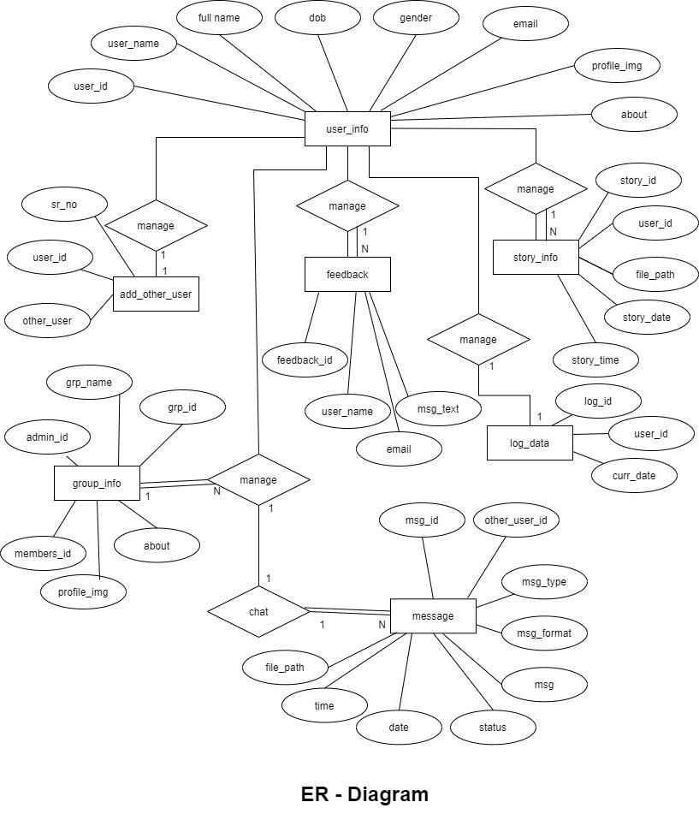

* 1. **Data flow diagram**
     1. **Introduction**

Data flow diagram is graphic tool to execute data flow analysis. This tool is used to analyse and describe the movement of data through the system which can be either automated or manual.

They focus on the data flowing into the system between process or outside the system towards data store. The activity of drawing DFD is divided into multiple levels and as levels are increased, depth of system description is also increased.

Therefore 1st level is responsible for presenting overview of system whereas expanded levels are describing single segment or process in the system. Basic level DFD is known as context DFD, where as further levels are known as 1st level and 2nd level DFD and so on

* + 1. **Types of DFD**

are divided into 2 basic main categories.

1. **Physical DFD**

The physical DFD is responsible for presenting model of current system and is used so that the current system can be clearly understood.

1. **Logical DFD**

Logical DFDs are model for proposed system. They are responsible for showing clearly the requirement on which new system should be built.

* + 1. **Notation for DFD**
* DFDs are designed in as way so that it will become easier to understand DFD as well as its base system.
* Even drawing DFD is also an easy task to perform because all drawn DFDs use unified notations to represent the system.
* These notations are divided into 2 categories……
  + - 1. Yourdon.
      2. Gane – Sarson.
* Four basic notations are used to draw DFD…
* **Data flow:**
* Notations used to show data flow is as shown under

|  |  |
| --- | --- |
| Yourdon | Gane – Sarson |
|  |  |

* + Data in any system moves in a specific direction (from origin to designation).
  + Therefor data flows indicate movement of data in the system.
  + Data flow must be inputs to and outputs from the processes.
  + All data flow activities must be labelled properly.
* **Process:**

|  |  |
| --- | --- |
| Yourdon | Gane – Sarson |
|  | Process name |

* Process are the activities which are performed to transform inputs into outputs.
* Process are the actions which are performed by people machine or computer on including data.
* It is important to remove always about data flow where output data flow is ­­­labelled differently from input data flow. Notations used to show process are as under…
* **Entity:**
* A person, machine or anything that performs process and either provides inputs or receives output is called an entity.
* There is a common symbol used for entity in both the categories.
* The notation used for an entity is as under.

|  |  |
| --- | --- |
| Yourdon | Gane – Sarson |
| **Entity Name** | |

* **Data store:**
* Data store is a file used to store data used within the system.
* It is responsible for storing as well as providing data as per user’s requirement.
* The notations used for data store is as bellow.

|  |  |
| --- | --- |
| Yourdon | Gane – Sarson |
| Data store | **Data store** |

* + 1. **Rules for DFD**
* Fix the scope of the system by means of context diagram.
* Organize the DFD so that the main sequence of the actions.
* Reads left to right and top to bottom.
* Identify all inputs and outputs.
* Identify and label each process internal to the system with rounded circle.
* A process is required for all the data transformation and transfer. Therefor, never connect a data store to a data source or the destinations or another data store with just a data flow arrow.
* There must not be unnamed process.
* Indicate external source and destinations of the data, with sequence.
* Number each occurrence of repeated external entities.
* Identify all data flows for each process step, except simple record retrievals.
* Label data flow on each.
* Use details flow on each arrow
* Use the details flow arrow to indicate data movements.
  + 1. **All diagram**

**Context level DFD**

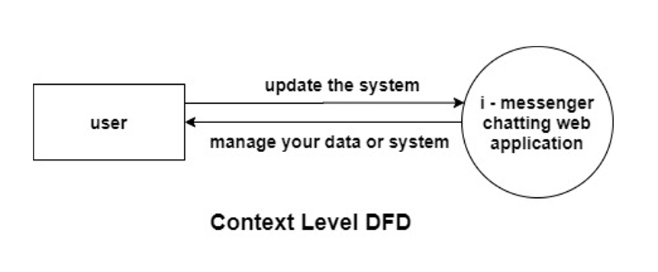

**1st level DFD**

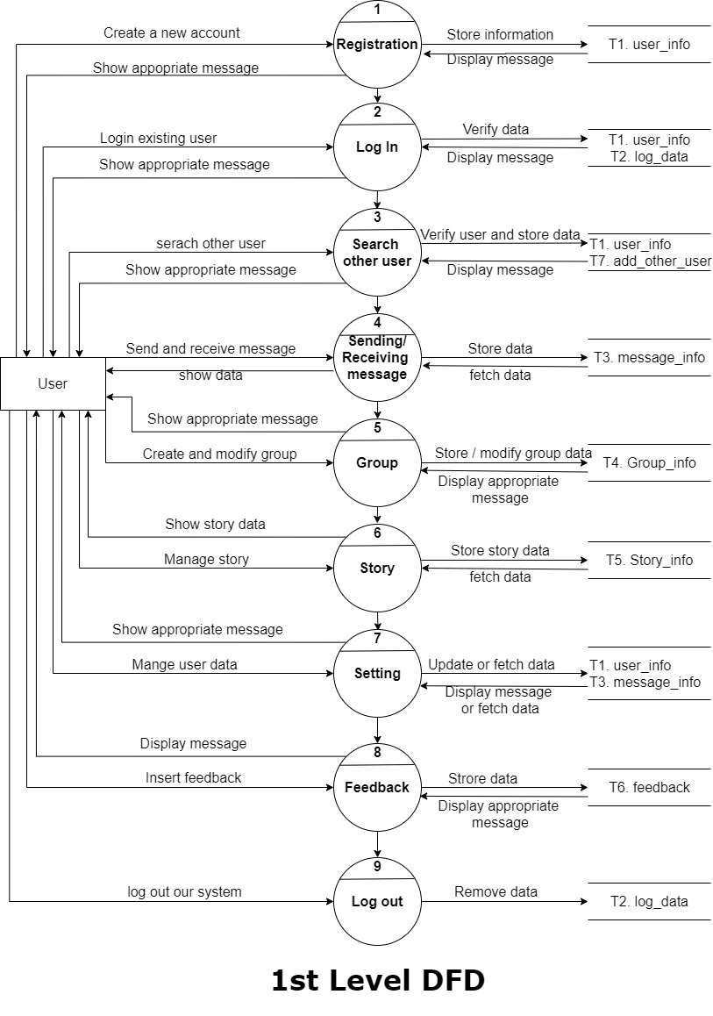

**2nd level DFD (Log In)**

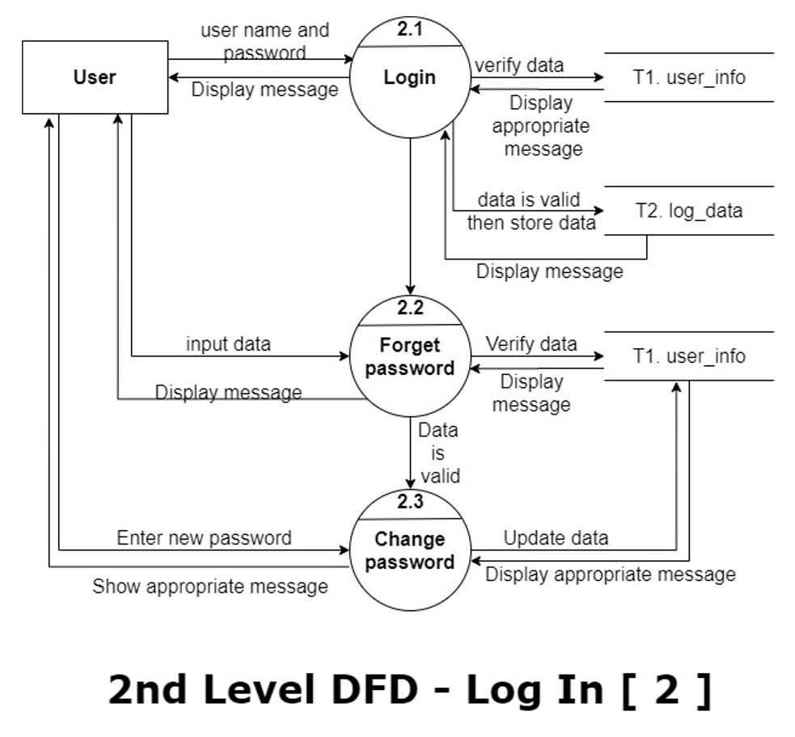

**2nd level DFD (Search user)**

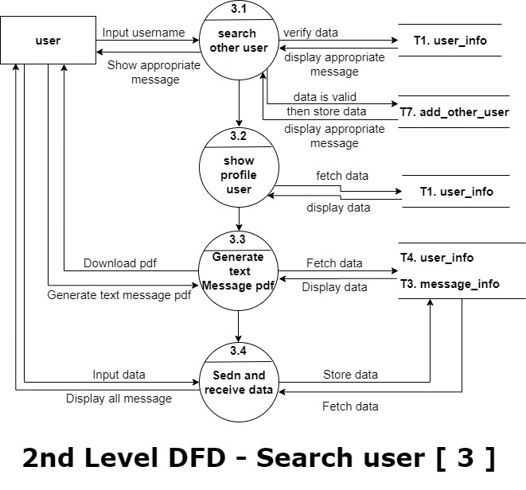

**2nd level DFD (Group)**

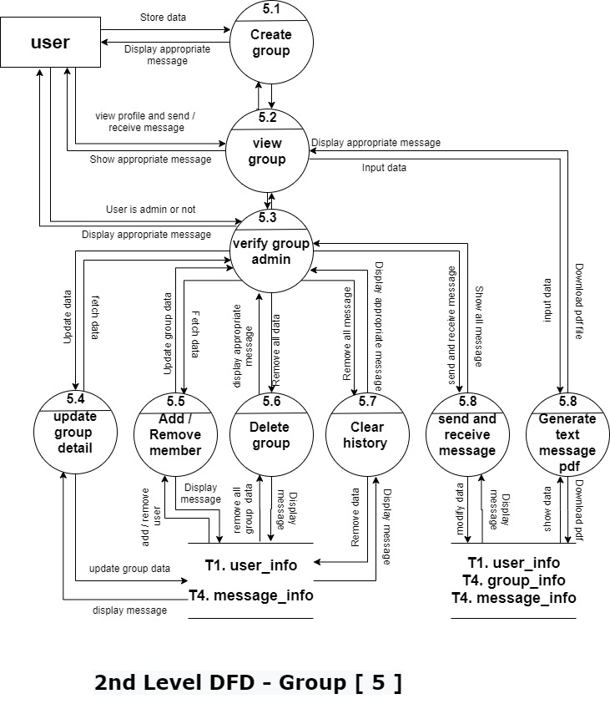

**2nd level DFD (Setting)**

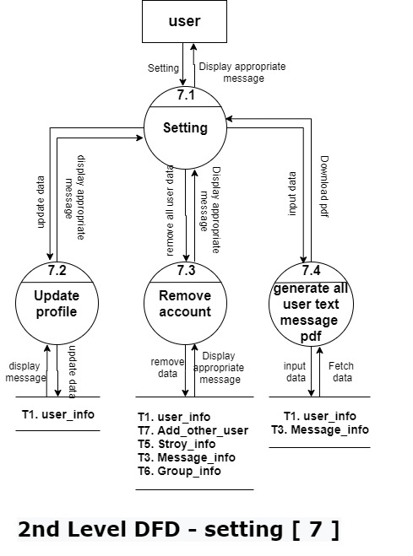

1. **Organization chart & Screen design**

**5.1. Organization chart**

**5.1.1. introduction**

**5.1.2. Organization chart**

**5.2. Screen Design**

* 1. **Organization chart** 
     1. **Introduction**
* Organizing, like planning, must be a carefully worked out and applied process.
* This process involves determining what work is needed to accomplish the goal, assigning those tasks to individuals, and arranging those individuals in a decision-making framework (organizational structure).
* The end result of the organizing process is an organization – a whole consisting of unified parts acting in harmony to execute tasks to achieve goals, both effectively and efficiently.
* A properly implemented organizing process should result in a work environment where all term members are aware of their responsibilities.
* If the organizing process is not conducted well, the result may yield confusion, frustration, loss of efficiently, and limited effectiveness.
  + 1. **How organization chart are used**

Organizational charts are useful in a number of ways. Here are a few of the ways your company or group can benefit from an organization chart.

* + Show work responsibilities and reporting relationships.
  + Allow leadership to more effectively manage growth or change.
  + Allow employees to better understand how their work fits into the organization’s overall scheme.
  + Improve lines of communication.
  + Create a visual employee directory.
  + Present other types of information, such as business entity structures and data hierarchies.

The type of organization chart you make should mirror the management philosophy and organizational structure of your company.

There are four basic types of organizational charts:

1. Functional Top – Down
2. Divisional structure
3. Matrix organizational chart
4. Flat organizational chart
   * 1. **Organization chart**

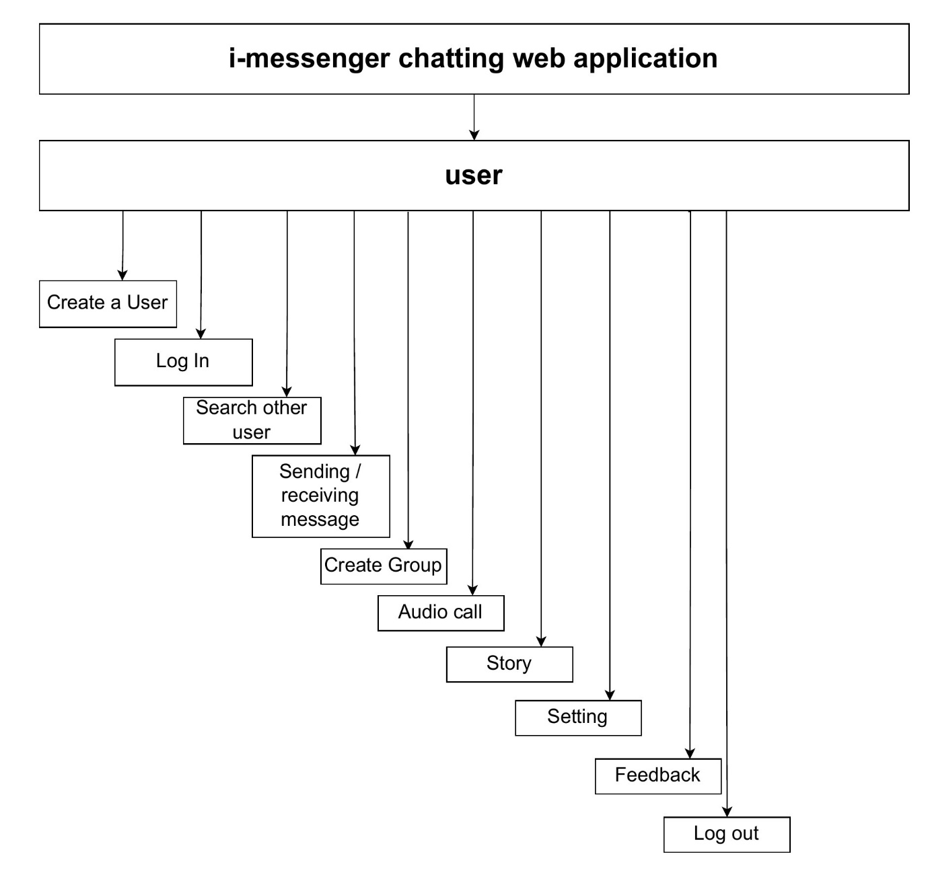

* **Organizational chart for group**

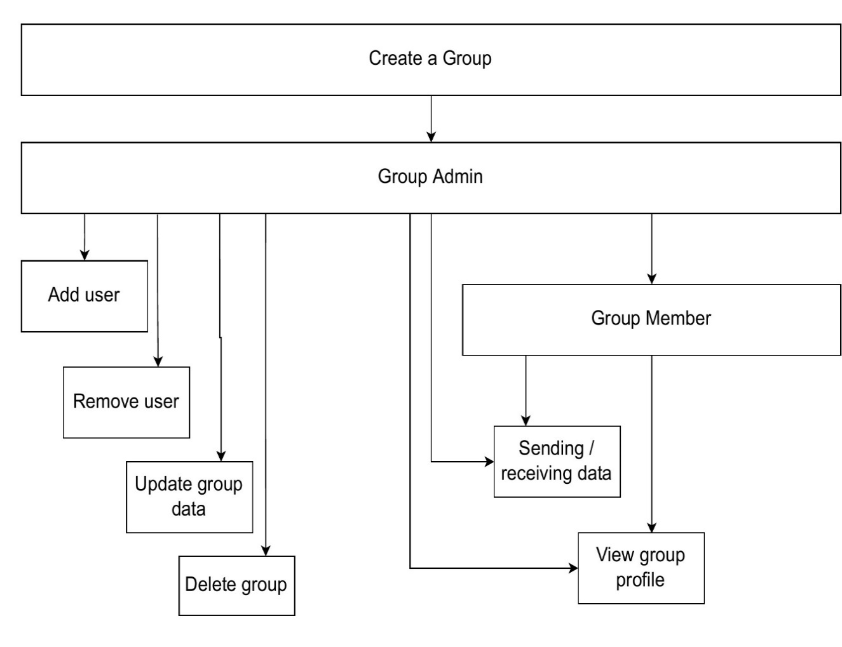

* 1. **Screen Design** 
     + 1. **Home page**

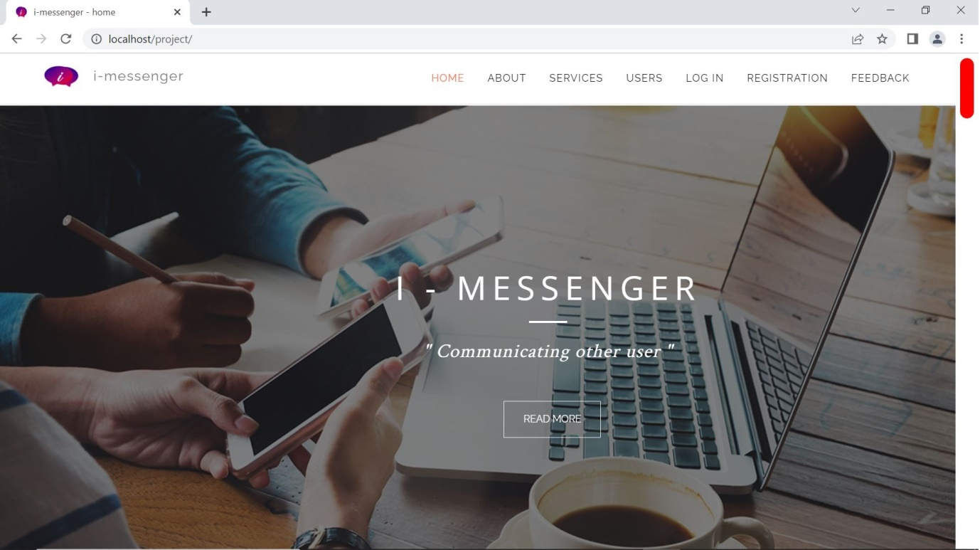

* + - 1. **About**

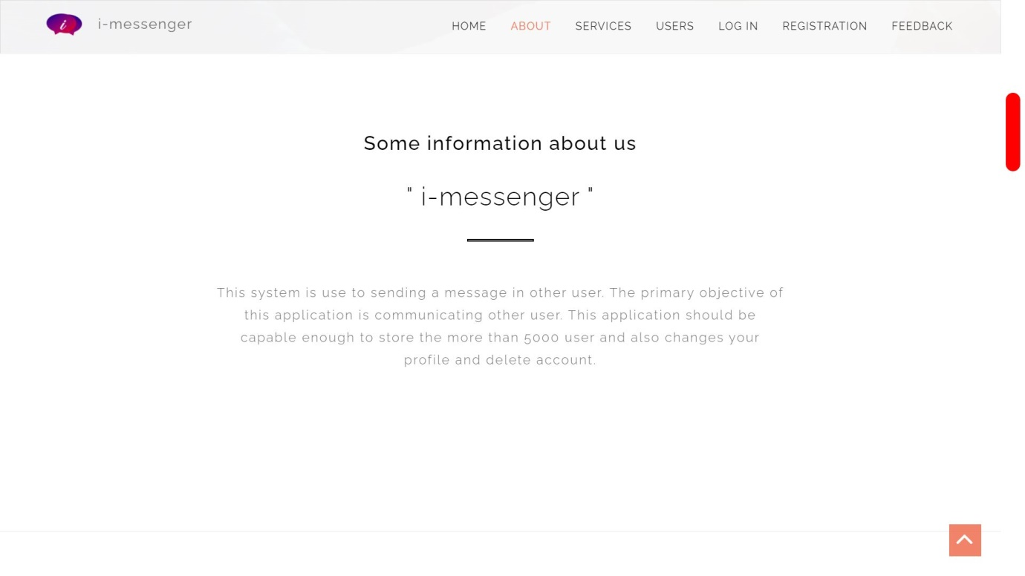

* + - 1. **Services**

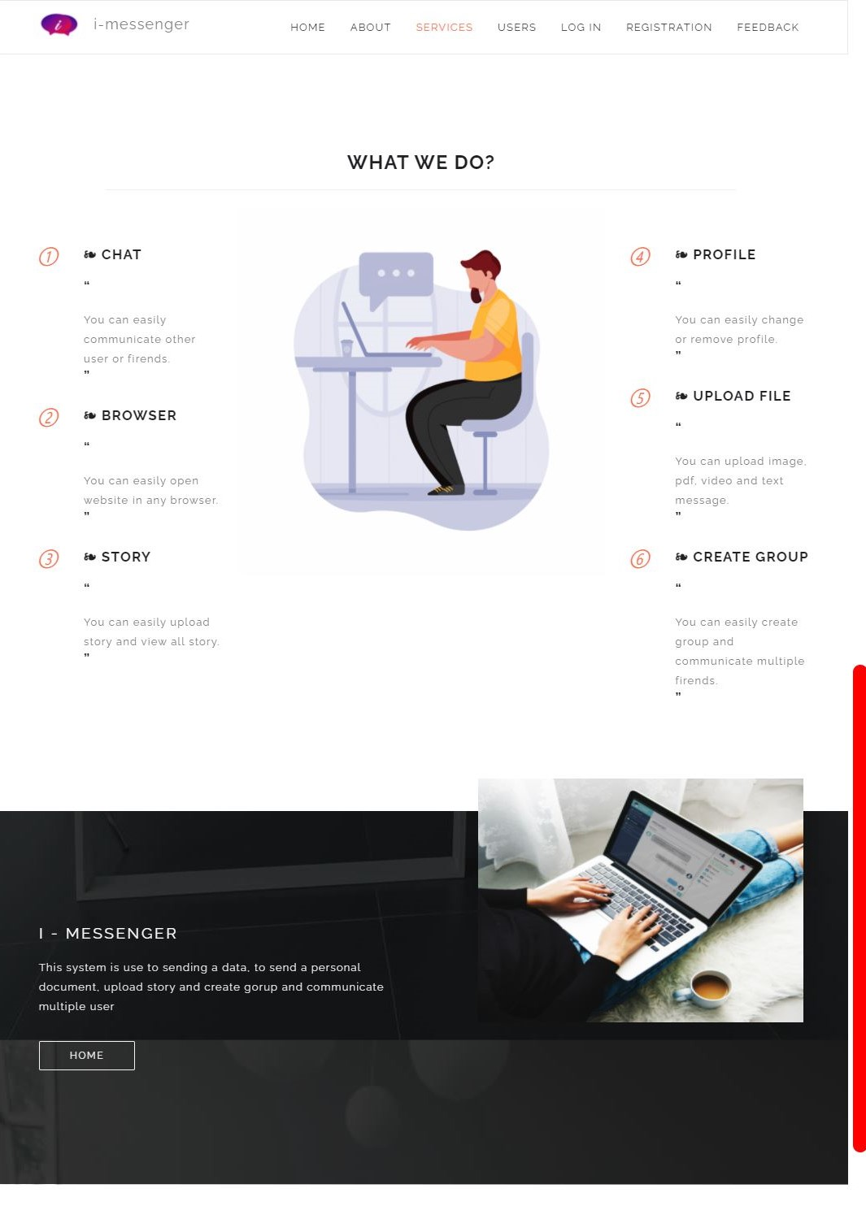

* + - 1. **Users**

User is show all user profile and hominy user join in our system, how many user is logged in our system and how many group in our system.

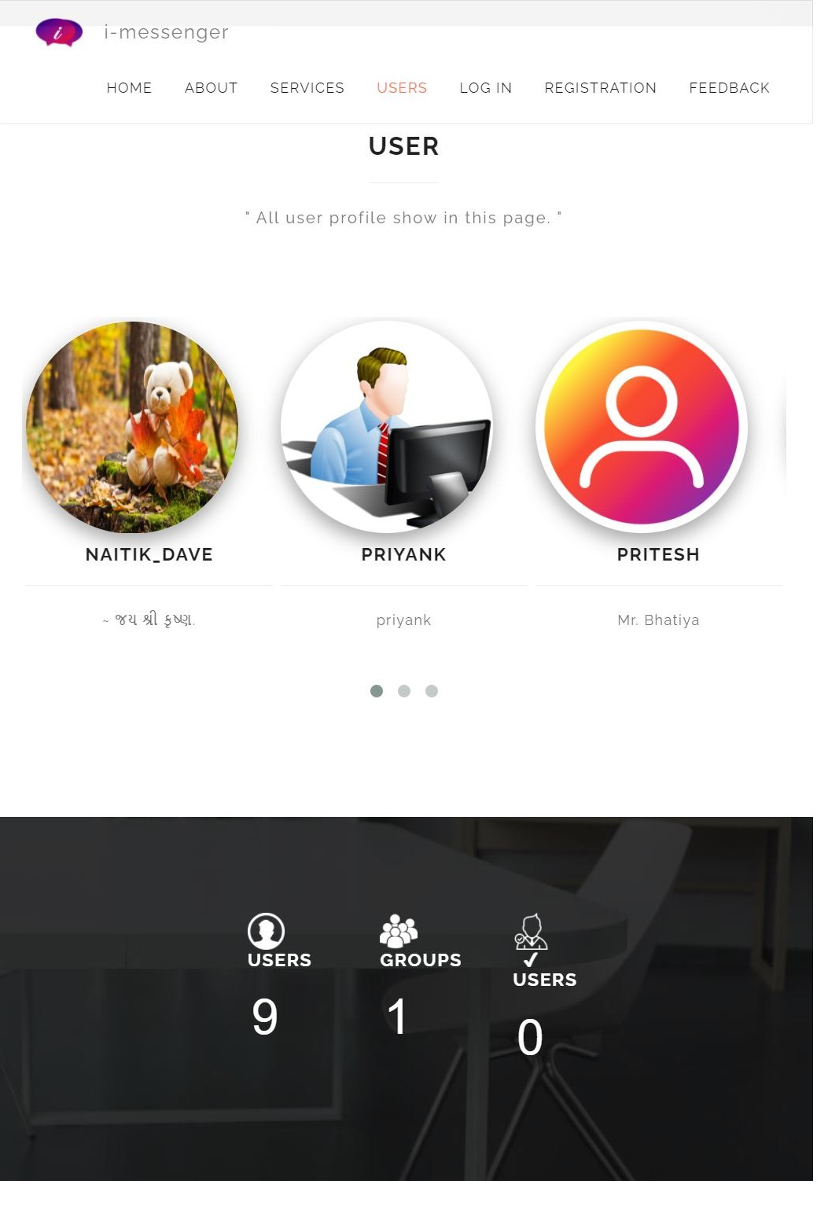

* + - 1. **Feedback**

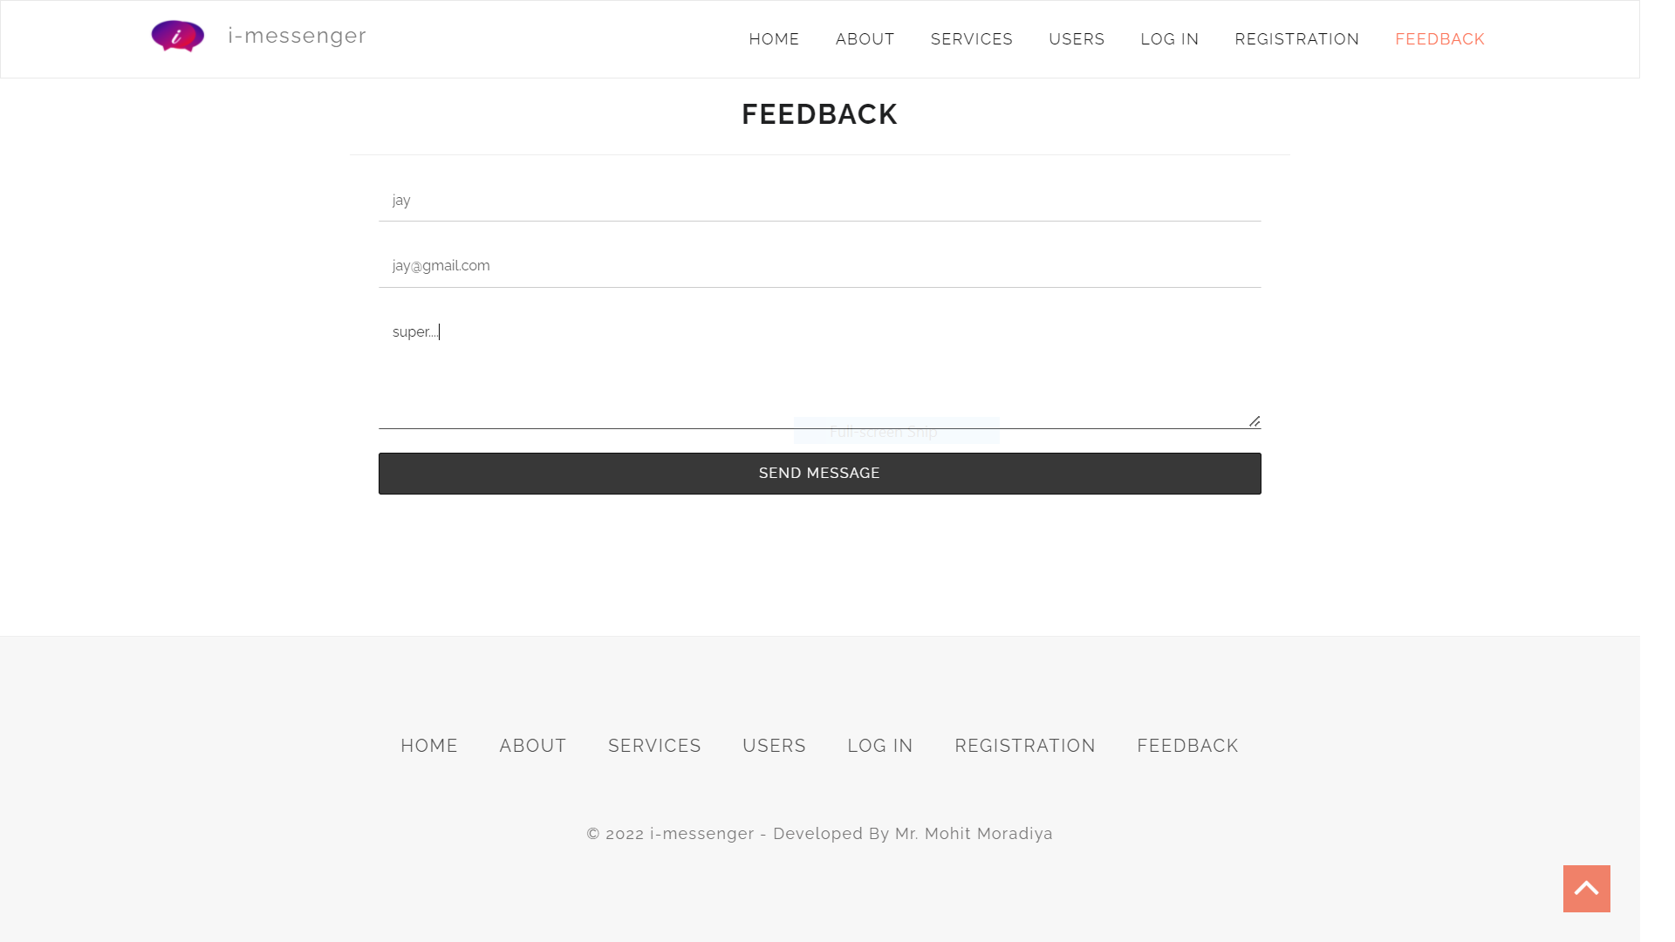

* + - 1. **Registration**

It is use to register a new account

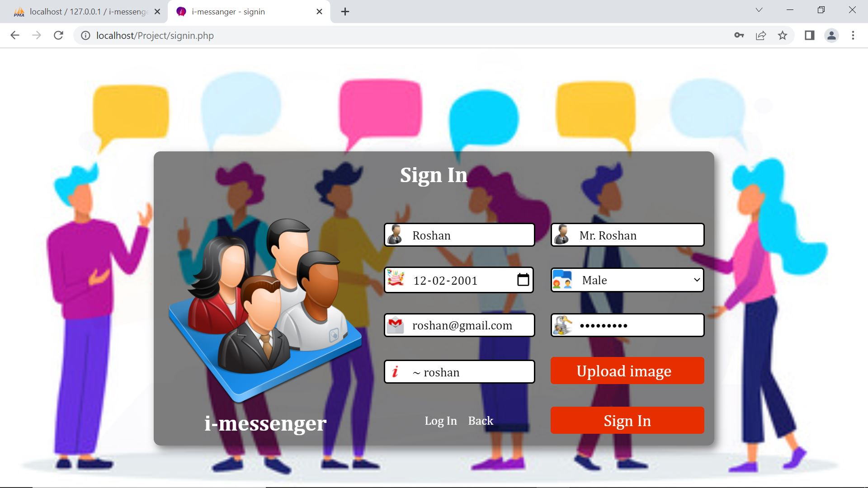

* + - 1. **Login**

It is use to login our system.

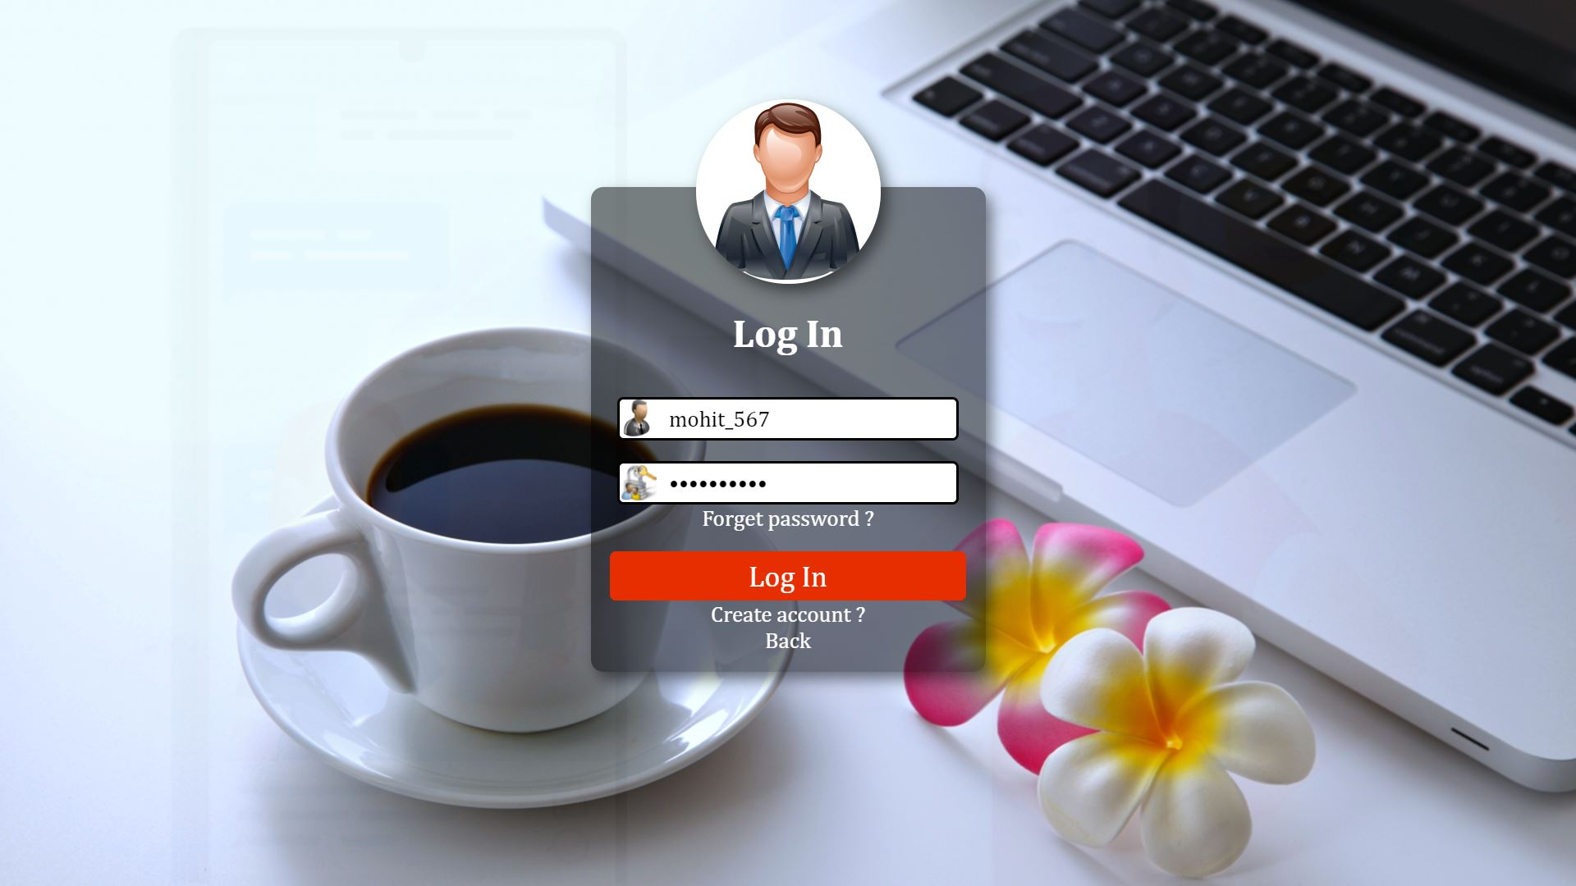

* + - 1. **User dashboard**

It is use to show user dashboard

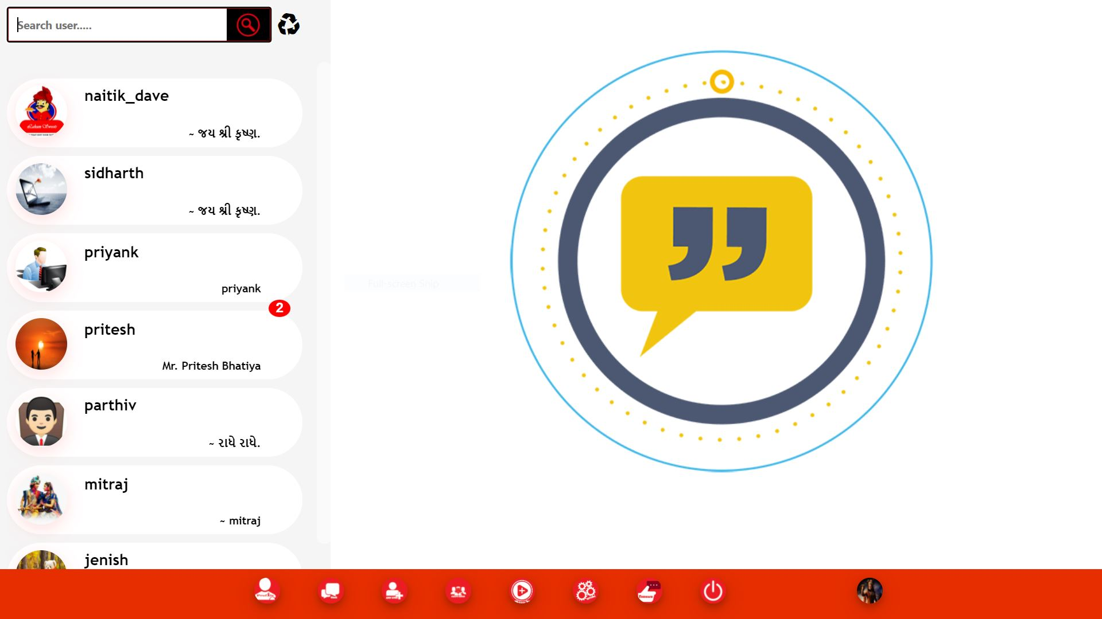

* + - 1. **All user box, and search user**

It is use to show all user and show unread message in user.

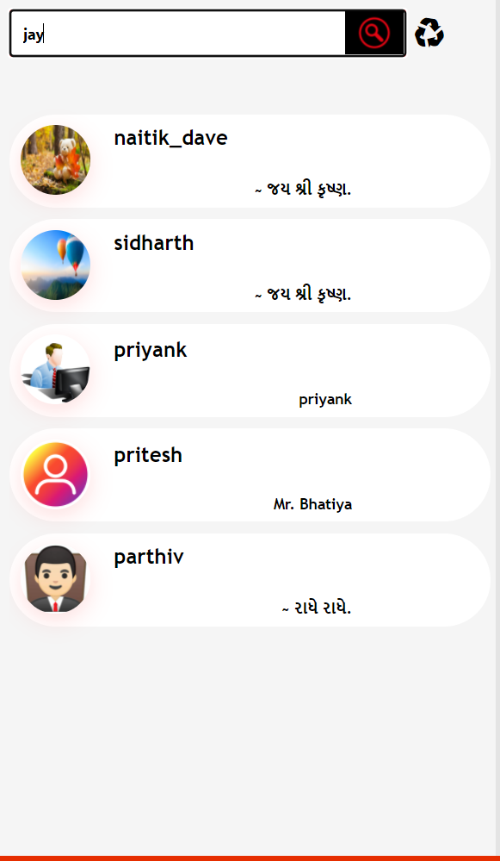

* + - 1. **Add other user**

It is use to add other user to communicate in this system.

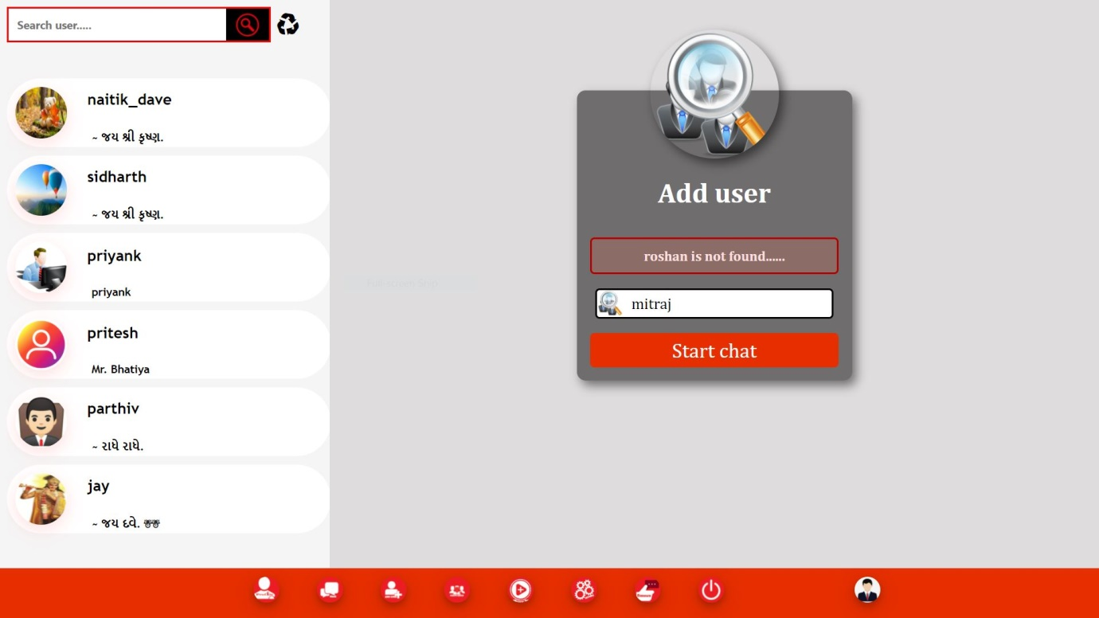

* + - 1. **Show other user profile**

It is use to show other use profile.

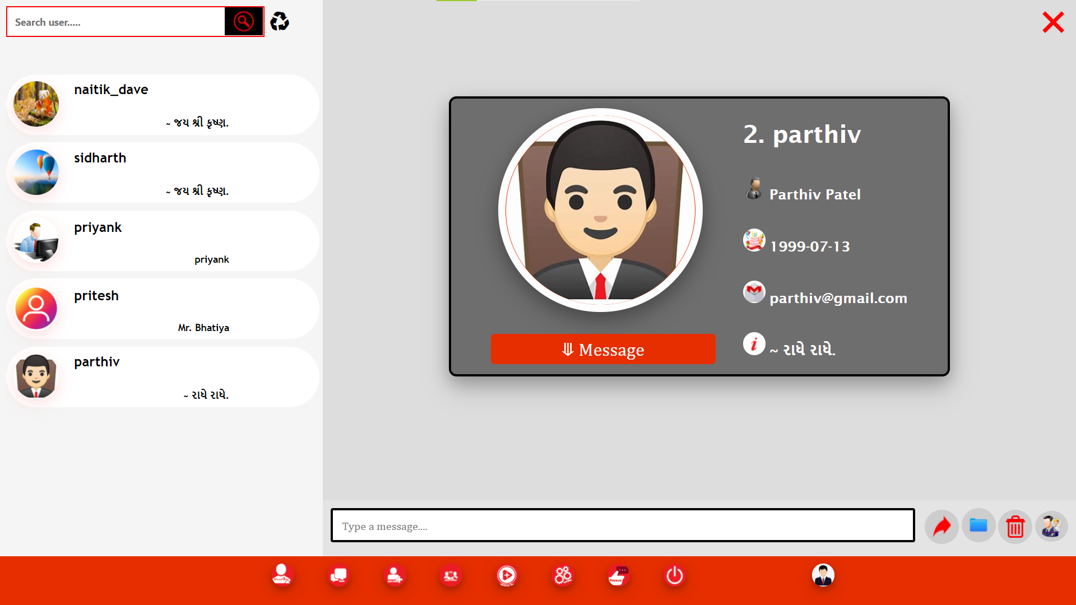

* + - 1. **Download message**

It is use to show menu like file message and text message.

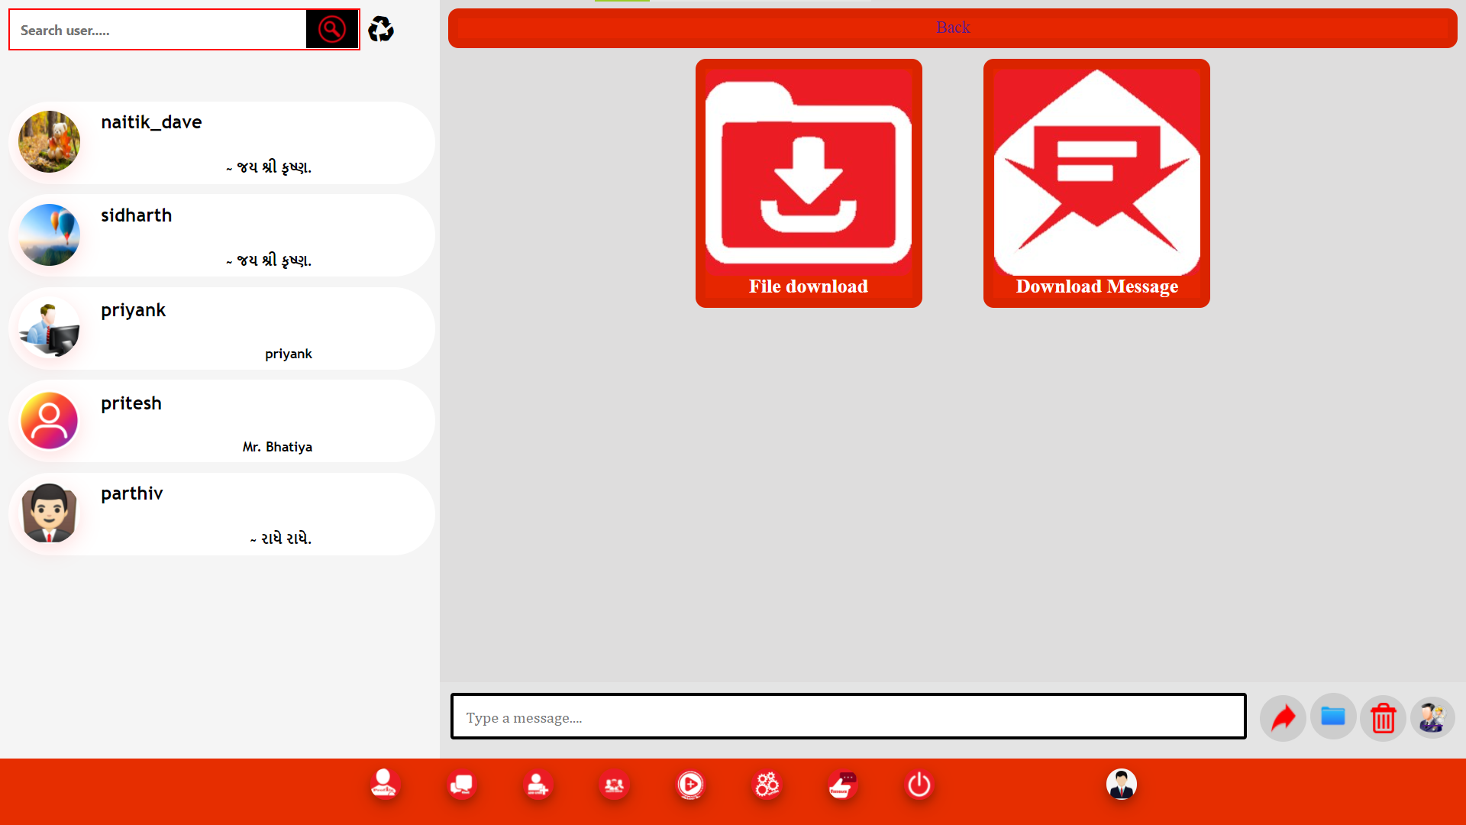

* + - 1. **File message**

It is use to particular other user to send or receiving file.

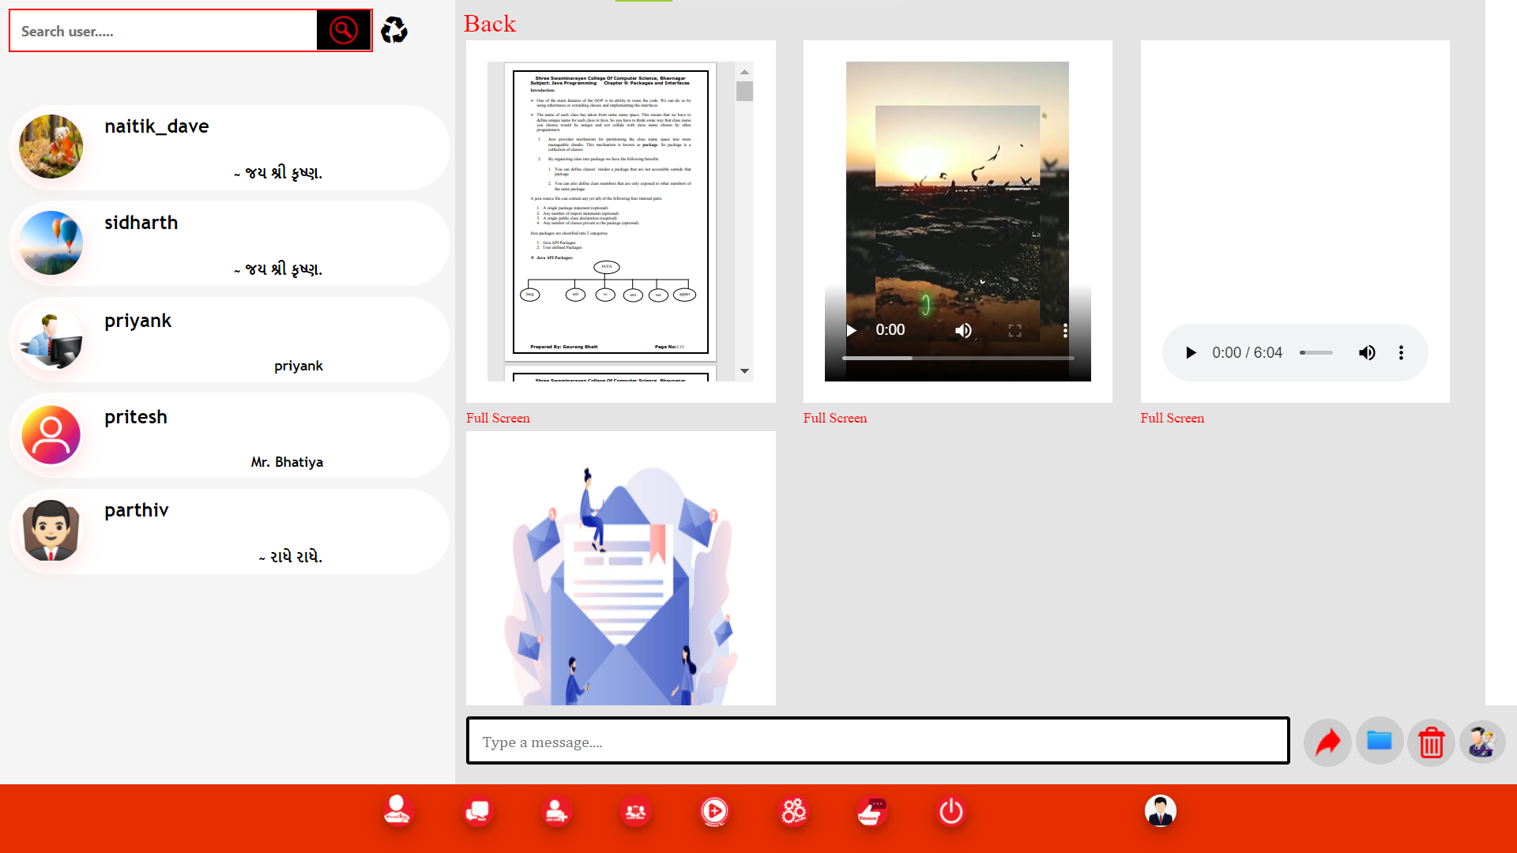

* + - 1. **Text message**

It is use to download important text message and generate pdf in other particular single user.

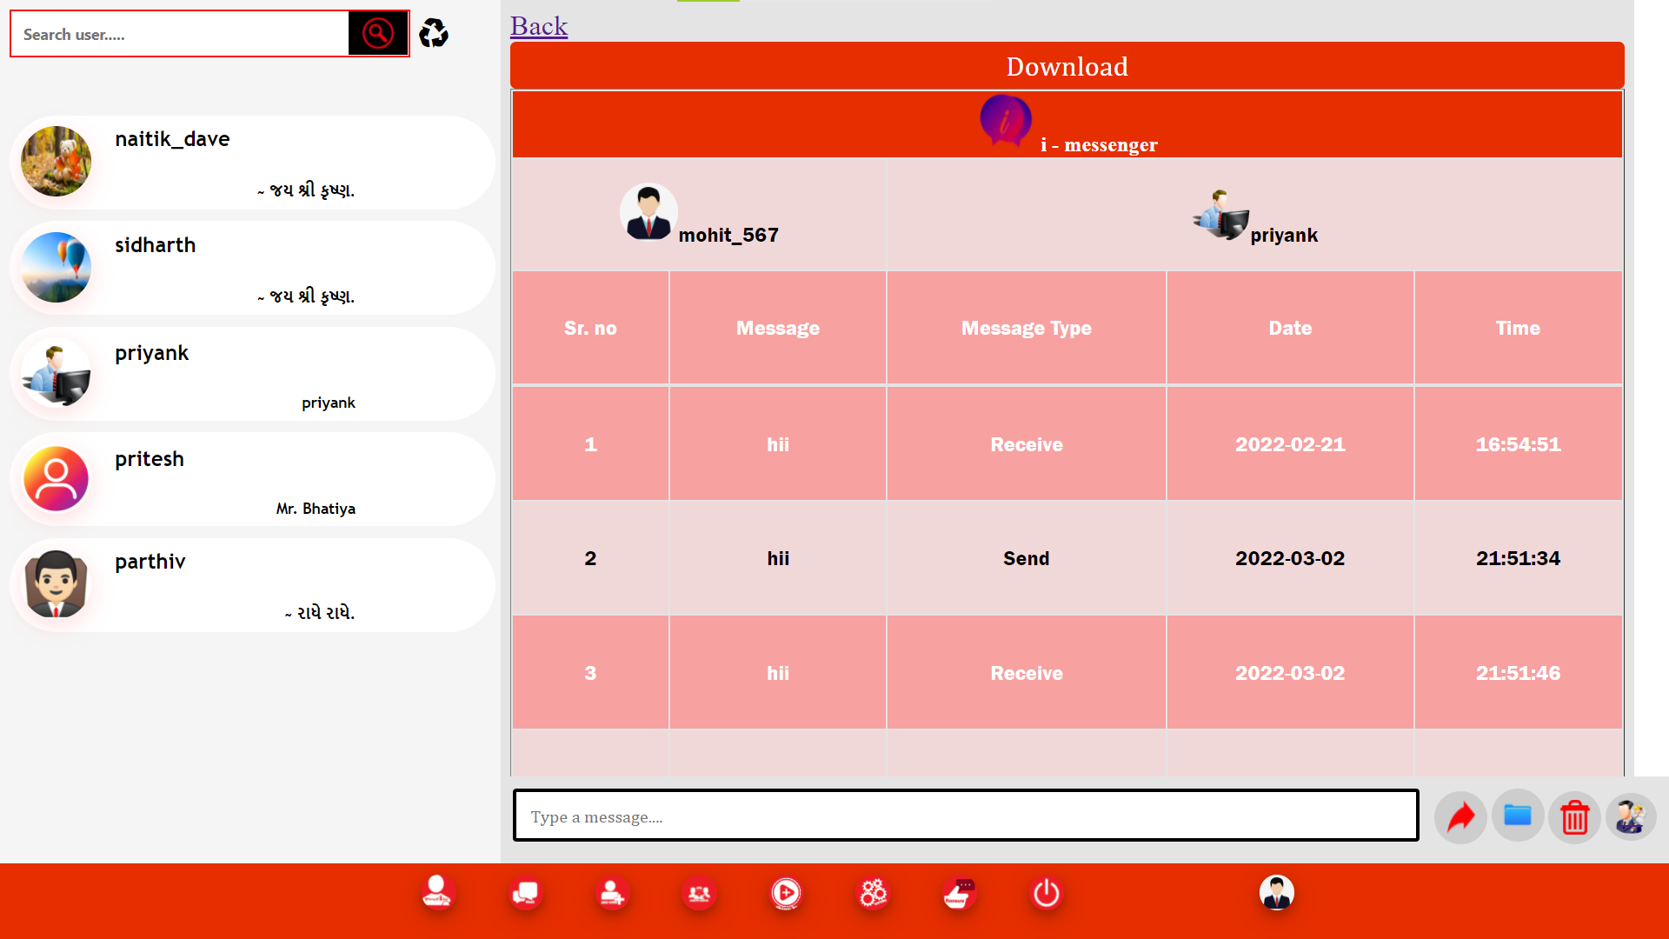

* + - 1. **View all group**

This page is show all group in group member, or group admin and crate group link.

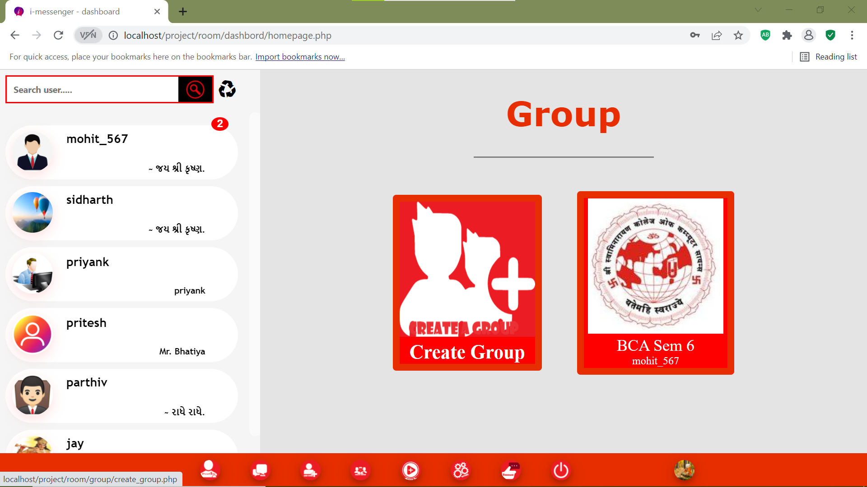

* + - 1. **Create a group**

Create a new group in this system

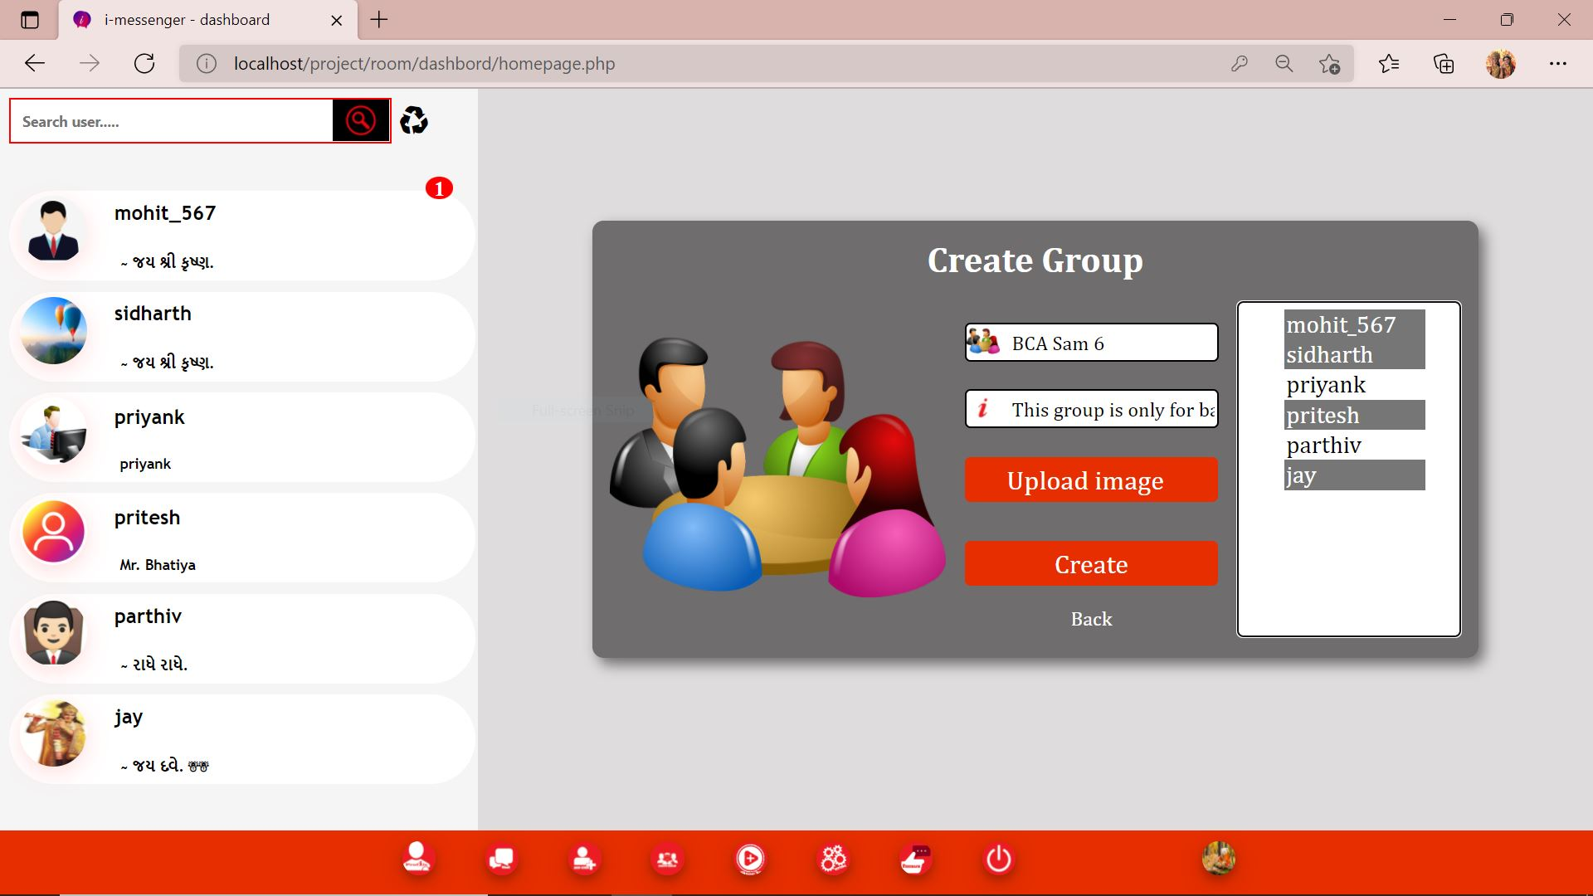

* + - 1. **Manage group profile**

If user is group admin at that modify group data and remove group.

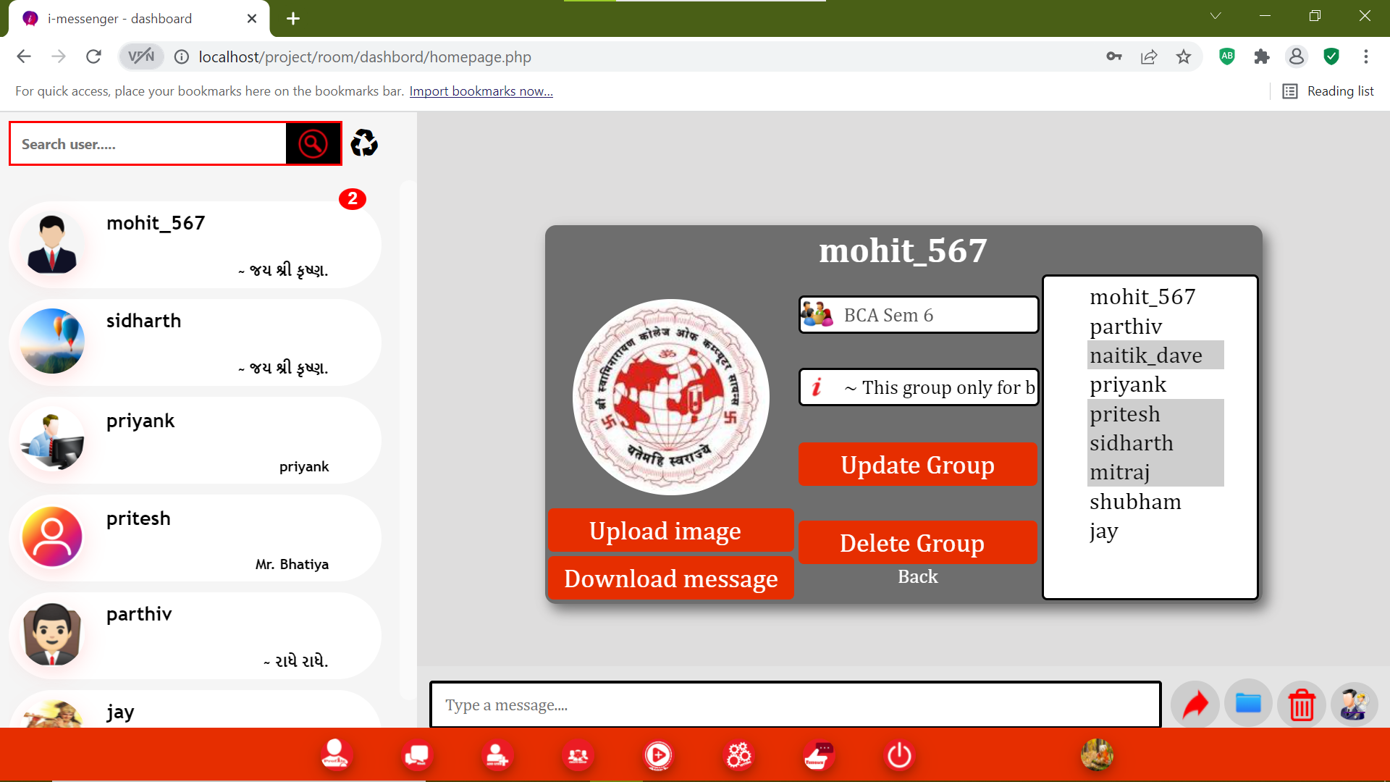

* + - 1. **Download group text message as pdf**

If group member or admin download important text message at that time store text message in this system.

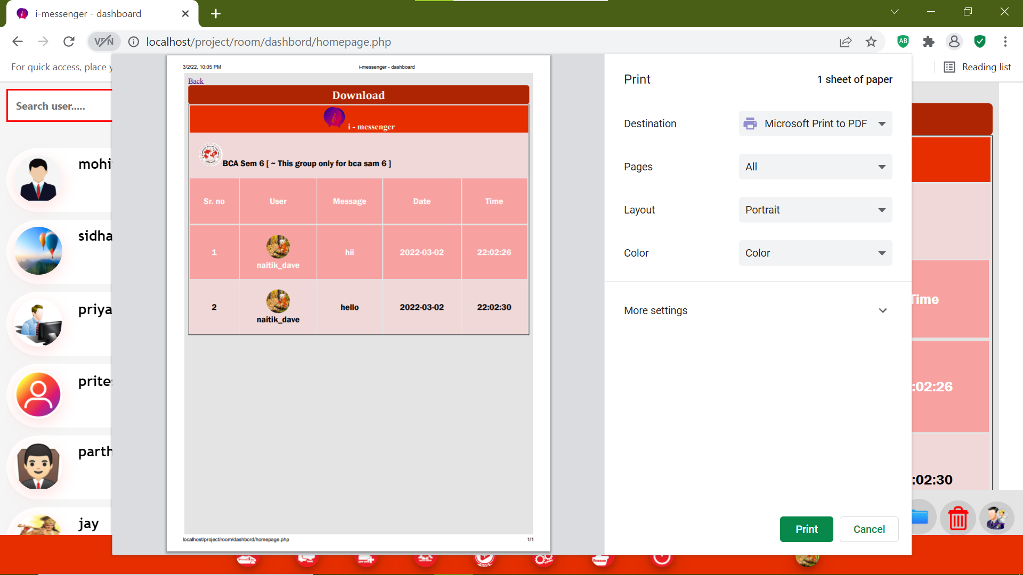

* + - 1. **View story**

This page is show all story in this sytem  
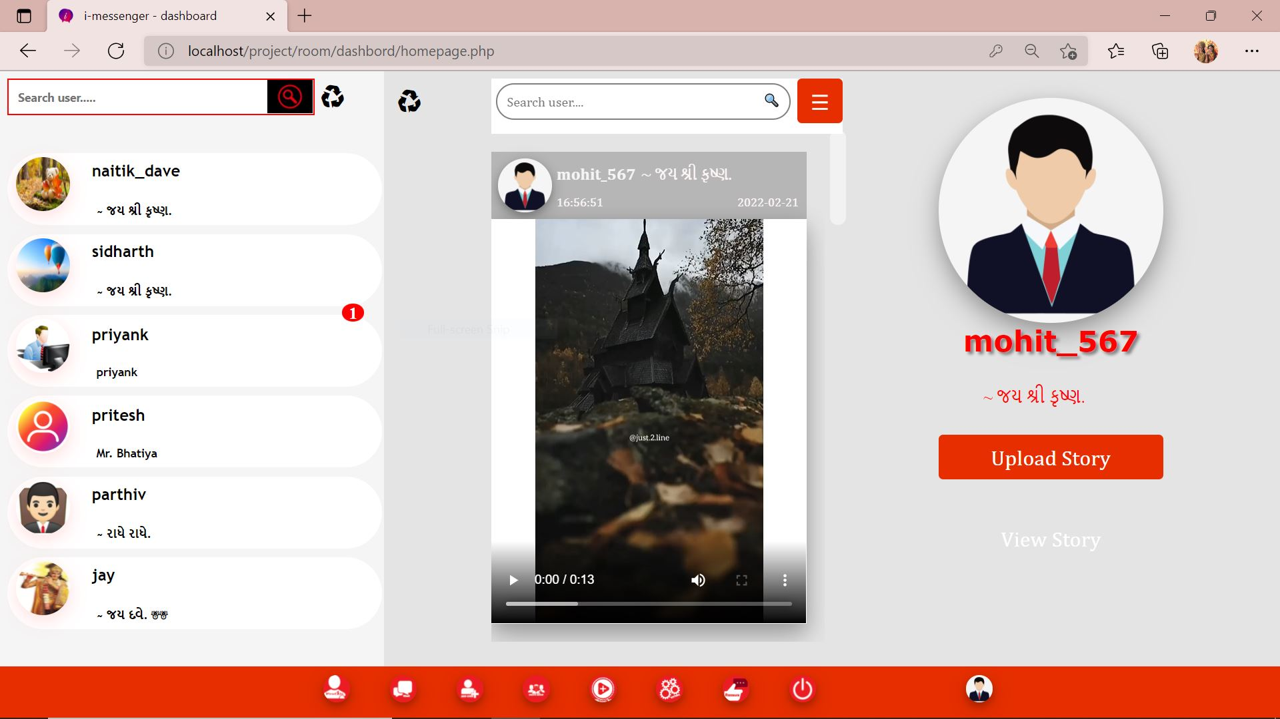.

* + - 1. **Upload story**

If user can upload the story at that time this page is use.

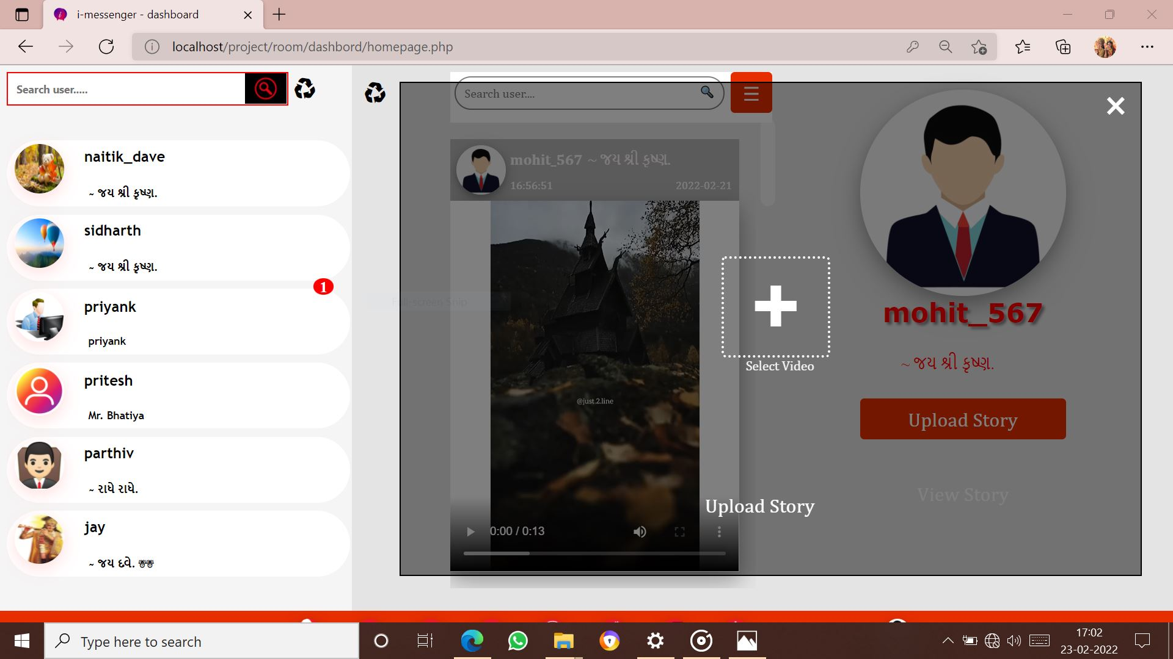

* + - 1. **Setting menu**

This page is menu of all setting.

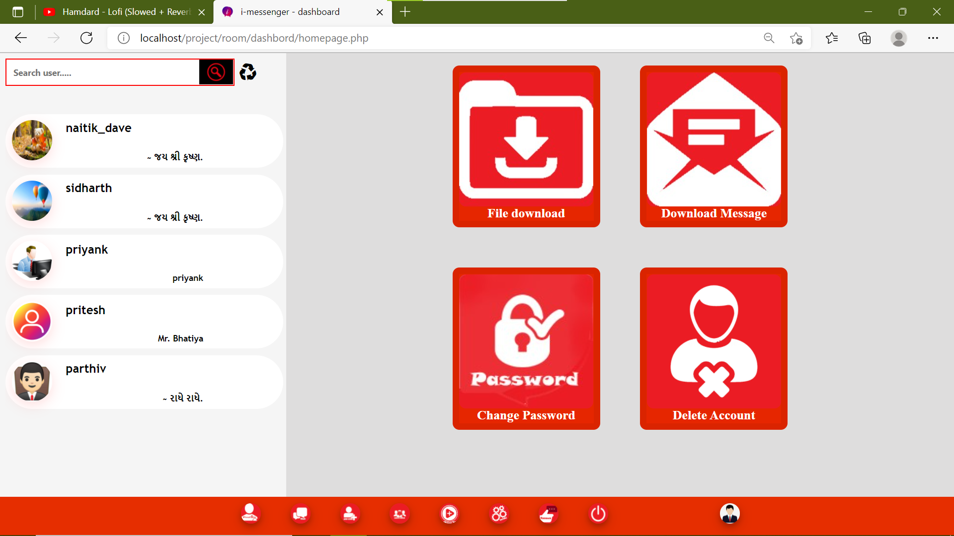

* + - 1. **Download all text message in all user**

If you can store all message to send or receive text message in all user then store data in pdf format.

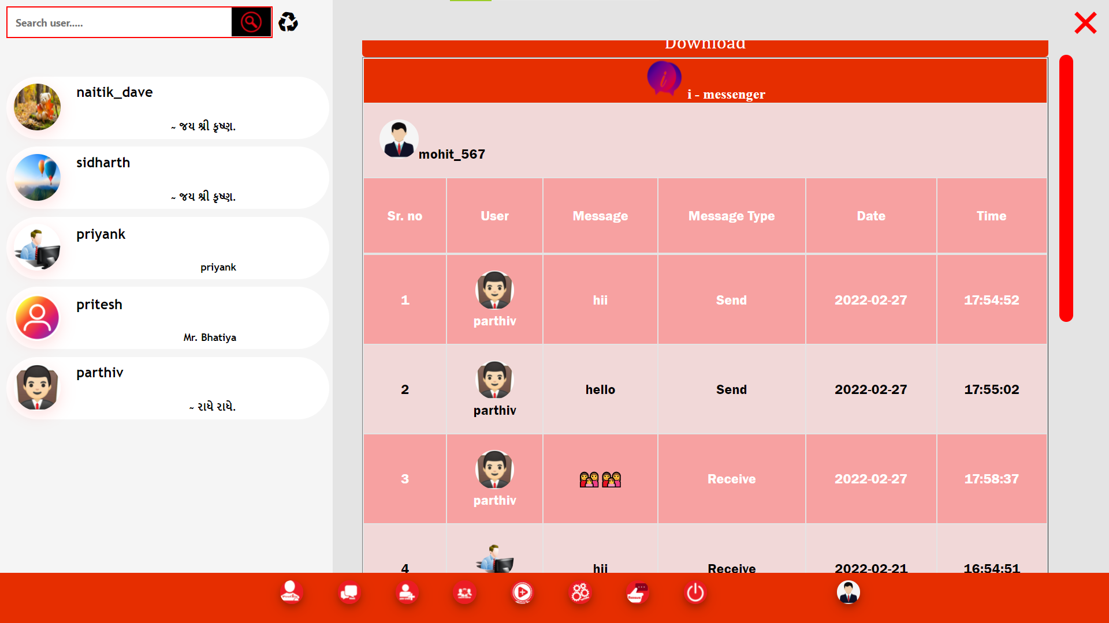

* + - 1. **File message in all user**

This page is use to show all file in user sending or receiving and preview of file.

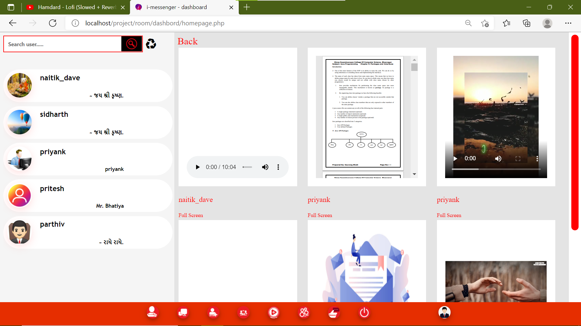

* + - 1. **Forget password**

This page is use to forget password.

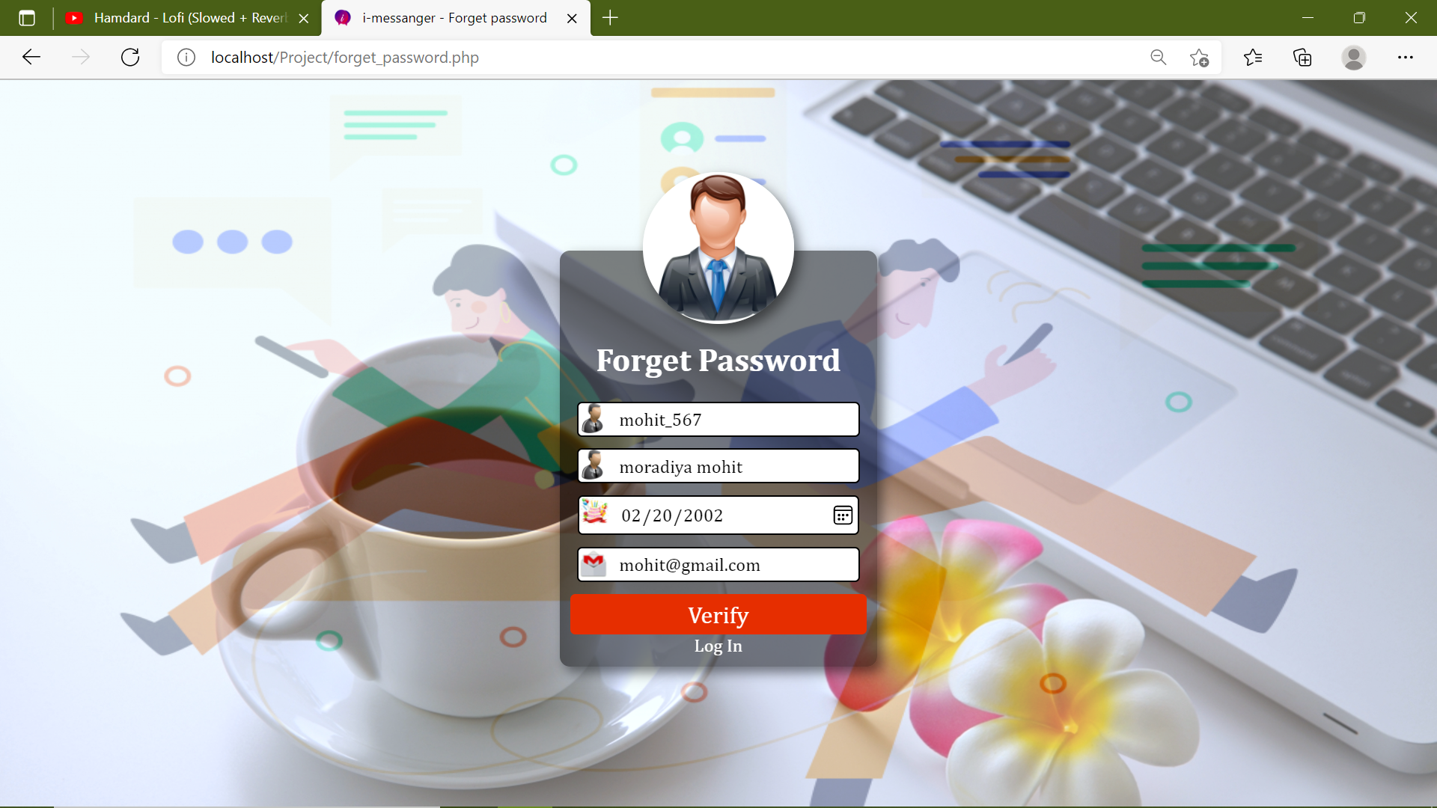

* + - 1. **Change password**

This page is use to change password.

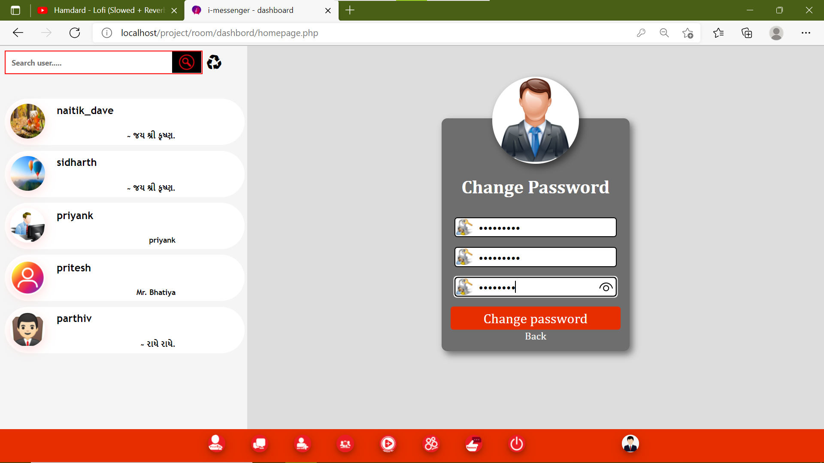

* + - 1. **View all feedback**This page is use to show all feedback in this system.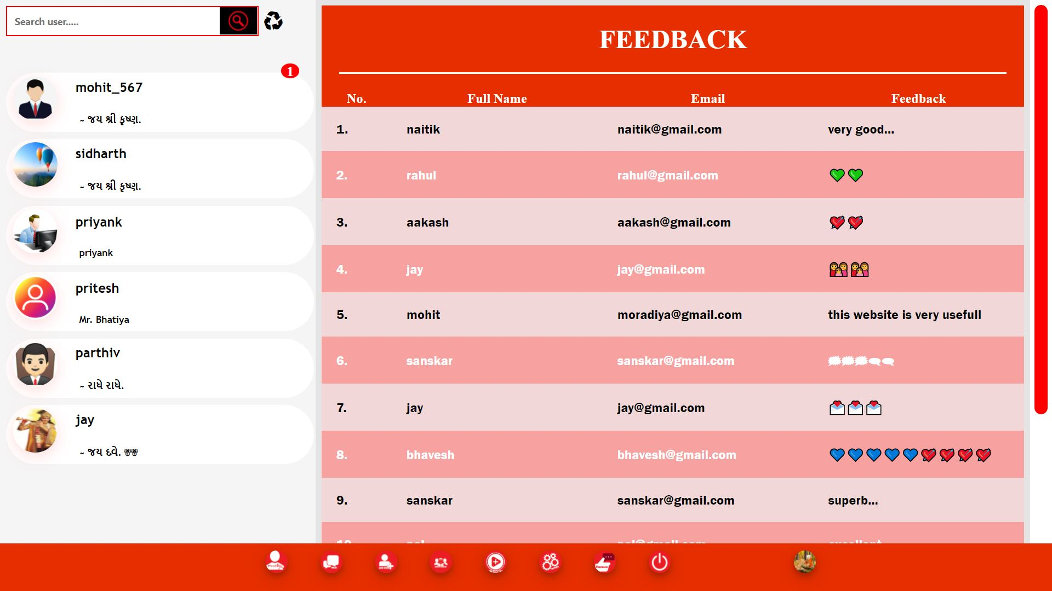
      2. **Update user profile**

This page is use to update your profile like change user image, email id etc.

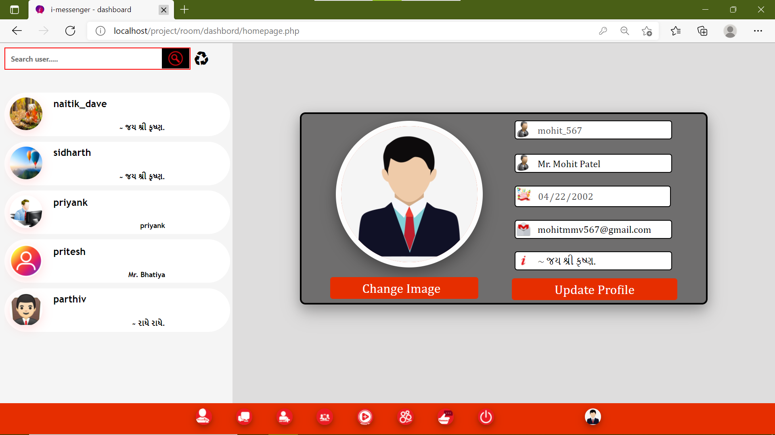

1. **Testing and test cases**

1. **Testing and test cases**
   1. **System testing, implementation and test cases Overview**
      1. **Introduction & objective**
      2. **Types of testing**
      3. **Level of testing**
      4. **Test cases introduction & parameter**
      5. **Test cases**

* **Introduction of system testing**
* System testing of the software or hardware is testing conducted on a complete, integrated system to evaluate the system’s agreement with its specified requirements.
* The process of performing a variety of tests on a system I to explore functionality or to identify problems is known as system testing.
* System testing is usually required before and after a system is put in place.
* Testers usually try to “break the system” by entering data that may cause the system to failure or return incorrect information
* System testing is a more limiting type of testing; it request to detect defects both within the “inner – collection” and also within the system a whole
* **Testing objectives**

1. Testing is a process of executing a program with the intent of finding an error.
2. A good test cases us one that has a probability of finding an as yet undiscovered error
3. A successful test is one that uncovers an undiscovered error.

* **Types of testing**
* Testing is an important step in software development life cycle.
* The process of testing takes place at various stages of development in programming.
* This is a vital step in development life cycle because the process of testing helps to identify the mistake and sends the program for correction.
* The various types of testing found in a software development life cycle are:

1. **White box testing**

* For doing this testing process the person have to access to the source code of the product to be tested.
* So, it is essential that the person doing this white box testing since this testing process requires the handling of source code.
* Through not necessary it would be more if the programmer itself does this white box testing since this testing process requires the handling of source code.
* It also known as clear box testing, open box testing, glass box testing, transparent box testing, code based testing or structural testing.

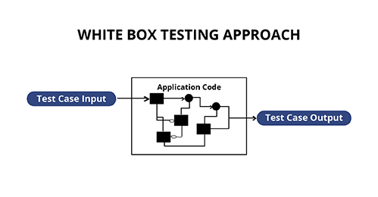

1. **Black box testing**

* This is otherwise called as functional testing.
* In opposite to white box testing here the person who is doing the black box testing need not have the programming knowledge.
* This is because the person doing the black box testing would access the output or outcomes as the end user would access and would perform through functionality testing to check whether the deployed module or product behaves in functionality in the way it has to be.

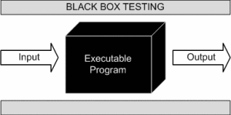

1. **Regression [Failure] testing**

* We all know that development life cycle is subjected to continuous changes as per the requirements of the user.
* Suppose if there is a change in the existing system which has already been tested it is essential that one has to make sure that this new changes made to the existing system do not affect the existing functionality.
* For ensuring this regression testing is done.
* Regression testing is the process of testing changes to computer programs to make sure that the older programming still works with the new changes.
* Regression testing is a normal part of the program development process and, in larger companies, is done by code testing specialist.

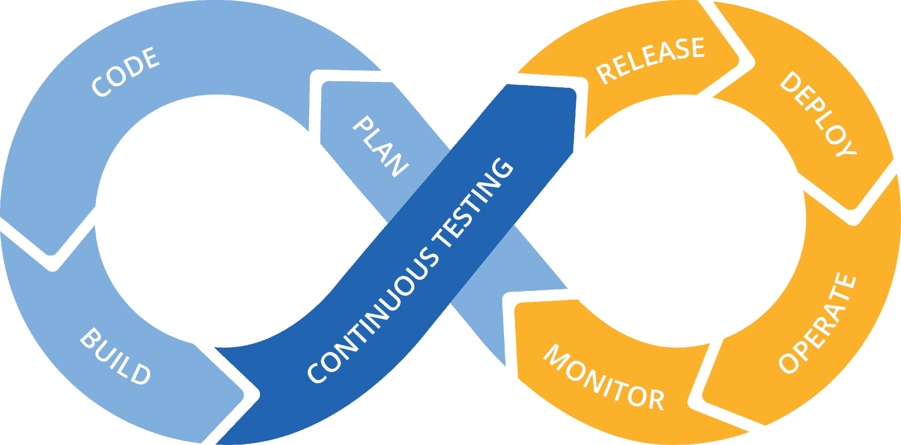

1. **Integration testing**

* Integration testing is a level of software testing where individual units are combined and tested as a group.
* The purpose of this level of testing is to expose faults in the interaction between integrated between integrated units.
* By doing the integration testing the process as a whole becomes easier.
* This is because by correcting mistakes or bugs in each module the integration of all units as a system and testing process becomes easier.
* So one might think why the integration is testing needed.
* The answer is simple.
* It is needed because unit testing as explained test and assures correctness of only each module.
* But it does not cover the feature of how the system would behave or what error would be reported when modules are integrated.

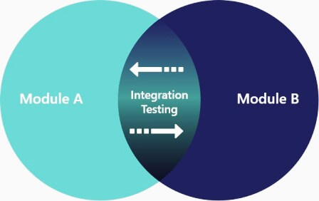

1. **Sanity [Smoke] testing**

* This is also called as smoke testing.
* This is mainly used to identify environmental related problems and is performed mostly by test manager.
* For any application it is always necessary to have the environment first checked for smooth running of the application.
* So in this testing process the application is run in the environment technically called as dry run and checked to find that the application could run without any problem or ignored in between.
* Sanity testing is the subset of regression testing and it is performed when we do not have enough time for doing testing. Sanity testing is the surface level testing where QA engineer verifies that all the menus, functions, commands available in the product and project are working fine.

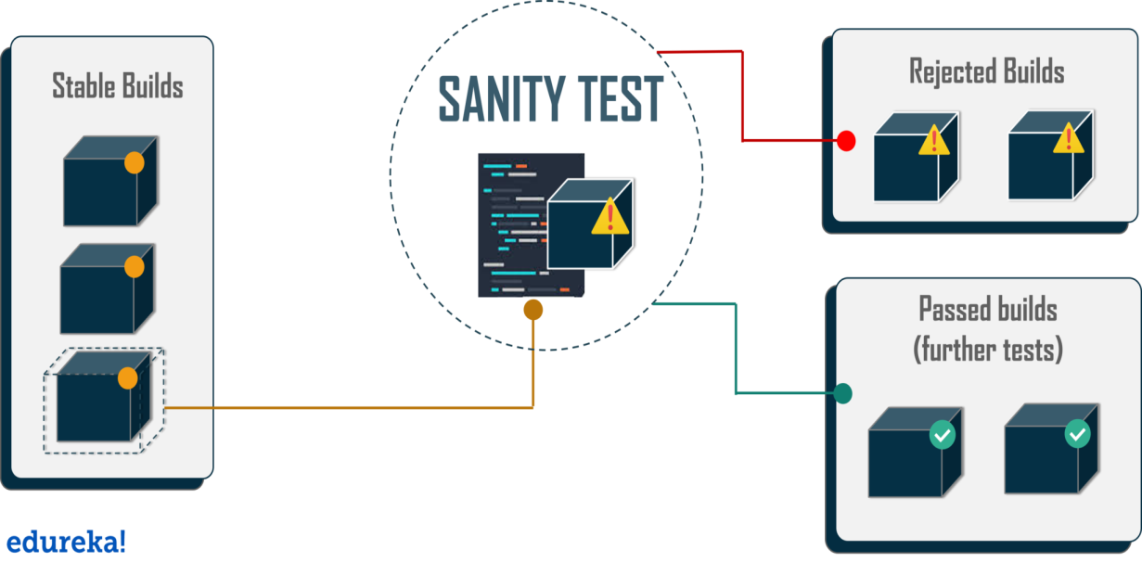

1. **Alpha testing**

* The above different testing process described takes place in different stages of development as per the requirement and needs.
* But a final testing is always made after a full finished product that is before it released to end users and this is called as alpha testing.
* The alpha testing involves both the white box testing and black box testing thus making alpha testing to be carried out in two phases.
* Alpha testing takes place at the developer's site by the internal teams, before release to external customers.
* This testing is performed without the involvement of the development teams.

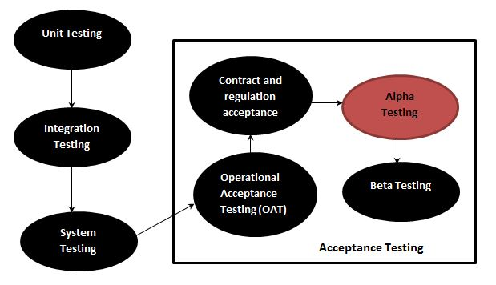

1. **Beta testing**

* This process of testing is carried out to have more validity of the software developed.
* This takes place after the alpha testing.
* After the alpha phase also generally the release is not made fully to all end users.
* The product is released to set of people and feedback is got from them to ensure the validity of the product.
* So here normally the testing is being done by group of end users and therefore this beta testing phase covers black box testing only.
* Beta Testing is one of the Acceptance Testing types, which adds value to the product as the end user (intended real user) validates the product for functionality, usability, reliability, and compatibility.

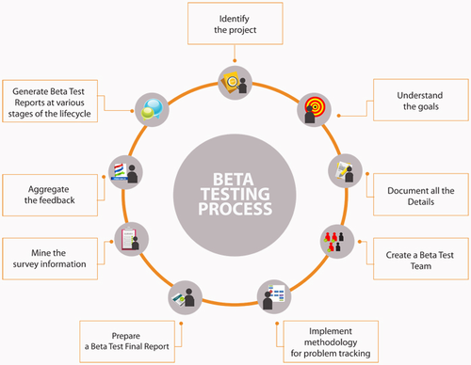

**Level of testing**

* Regardless of which strategy the analyst follows, there are preferred practices to ensure that test was successful.
* The level of test and types of test data combine with testing libraries are important feature for the actual testing process.
* System is not designed as entire systems nor are they tested as single system, the analyst is required to perform both:

1. **Unit testing**

* In unit testing the analyst tests the programs making up a system.
* The software units in the system are the modules or routines that are assembled and integrated to perform specific function.
* Unit testing focuses first on modules, independent from one another to locate errors.
* This enables a tester to detect errors in coding and logic that contain within that module alone.
* Unit testing can be performed from the bottom-up, starting with the smallest and lowest-level module and proceeding one at a time.

1. **System testing**

* System testing tests entire system which is considered integration of individual modules.
* It is also responsible for finding dependencies between the system and in original objective current specifications and system documentation.
* System testing is also responsible for resizing file size which must be adequate to satisfy user needs.
* **Test cases**
  + **Introduction**

A test case is document, which has a set of test data, preconditions, expected results, and post conditions, developed for a particular test scenario in order to verify compliance against a specific requirement.

Test case acts as the starting point for the test executions, and after applying a set of input value; the application has a definitive outcome and leaves the system at the system at some endpoint or also known as execution post condition.

* + **Typical test cases parameters :**

1. **Registration verification**

|  |  |
| --- | --- |
| Test Case ID | 1 |
| Name | Registration verification |
| Description | This test case is verified data are valid or not. If data is valid at that time navigate login. Otherwise appropriate message in registration form. |
| Input data | * Enter valid username * Enter full name * Enter valid birthdate * Enter gender * Enter valid email id * Enter valid password * Enter about * Upload image (.jpg, .png, .jpeg) and file size (2MB) |
| Expected output | * System need to verify data is valid or not.   **Case 1:**   * If data are not filling at that time print appropriate message. * If username match our application in My SQL database at that time print message “user is already exist”. * If password length is minimum 8 character. Otherwise print message “Password length minimum 8 character…”   **Case 2:**   * If file uploading at that time verify file size and file extension if file size and file extension not valid at that time print “File type and size not allow…” message. * If birthdate is not valid (5 year old) at that time print message “Birthdate is not valid”.   **Case 3:**   * If all data is valid at that time navigate login page and print message “Registration is successfully…”. |
| Actual output | System allowed registration and add data in database. And navigate login page. |

1. **Login verification :**

|  |  |
| --- | --- |
| Test Case ID | 2 |
| Name | Login verification |
| Description | This test case is verified username and password are valid or not. If data is valid at that time navigate user dashboard. Otherwise appropriate message in login page. |
| Input data | * Enter valid username * Enter valid password |
| Expected output | * System need to verify data is valid or not of our website database My SQL database.   **Case 1:**   * If data are not filling at that time print appropriate message.   **Case 2:**   * If user name and password are not valid at that time print message “Username and password is invalid”   **Case 3:**   * If username and password are valid at that time navigate user dashboard. |
| Actual output | System allowed login and navigate use dashboard. |

1. **Forget password verification :**

|  |  |
| --- | --- |
| Test Case ID | 3 |
| Name | Forget password verification |
| Description | This test case is verified data are valid or not. If data is valid at that time navigate change password. Otherwise appropriate message. |
| Input data | * Enter valid username * Enter full name * Enter valid birthdate * Enter valid email id |
| Expected output | * System need to verify data is valid or not in website My SQL database.   **Case 1:**   * If data are not filling at that time print appropriate message. * Id data is not valid at that time print message “Data is not valid”   **Case 2:**   * If data is valid at that time input new password and confirm password. And verify password length is not valid at that time print message “Password length minimum 8 character…”.   **Case 3:**   * If data is valid at that time input new password and confirm password. And verify password length is valid at that time change a password and navigate user dashboard. |
| Actual output | If all data is valid then update password in database and navigate user dashboard. Otherwise print appropriate message. |

1. **Add other user :**

|  |  |
| --- | --- |
| Test Case ID | 4 |
| Name | Add other user |
| Description | This test case is add other user. |
| Input data | * Enter valid username |
| Expected output | * System need to verify username.   **Case 1:**   * If user is not found at that time print message “User name not found…”   **Case 2:**   * If username is already added in our friends at that time print message “username is already exist”.   **Case 3:**   * If username valid and data is not found at that time print message “user successfully added” |
| Actual output | If data is valid then update our friends list and refresh a user panel at that time show this user. |

1. **Search user in user panel**

|  |  |
| --- | --- |
| Test Case ID | 5 |
| Name | Search user in user panel |
| Description | This test case is verify a user. |
| Input data | * Enter valid username |
| Expected output | * System need to verify username.   **Case 1:**   * If user is not found at that time show all other user in user panel.   **Case 2:**   * If username is found at that time show a user profile. |
| Actual output | If user is valid then show a user profile n user panel. Otherwise show all user in user panel |

1. **Sending a message and file**

|  |  |
| --- | --- |
| Test Case ID | 6 |
| Name | Sending a message and file. |
| Description | This test case is verify a message and uploaded file. |
| Input data | * Enter message * Uploaded valid file * Click on send button * Click delete button |
| Expected output | * System need to verify data.   **Case 1:**   * If user is not selected at that time user cannot send a message * If message or file not uploaded at that time not work send massage.   **Case 2:**   * If input a message at that time send a message and show user message box.   **Case 3:**   * If uploaded file is not valid extension or size (500MB) at that time not uploaded file. * If file and message is valid at that time send a file or message and show user message box all message.   **Case 4:**   * If click on delete button at that time remove all message or file in database. |
| Actual output | * If data is valid at that time add appropriate data. And show all message in user message box. * If click on delete button at that time remove all message in database and user message box is blank. |

1. **Story verification:**

|  |  |
| --- | --- |
| Test Case ID | 7 |
| Name | Story verification |
| Description | This test case is verify a uploaded story. |
| Input data | * Uploaded story (file type is .mp4 or .mp4a file size is less than 500MB) * Search username * Click on view story |
| Expected output | * System need to verify username.   **Case 1:**   * If file is not uploaded and click upload button at that time print a message “file is not uploaded…” * If file type and extension is not valid at that time print a appropriate message.   **Case 2:**   * Uploaded story is valid at that time add data in database and show a story in story box.   **Case 3:**   * If search user name is not found at that blank story box. * If user name is found at that time user’s all story show in story box.   **Case 4:**   * If click on view story at that time show all story in user in story box. |
| Actual output | If user is valid then show a user profile n user panel. Otherwise show all user in user panel |

1. **Create a group verification :**

|  |  |
| --- | --- |
| Test Case ID | 8 |
| Name | Create group verification |
| Description | This test case is verifying a create group data. |
| Input data | * Enter valid group name * Enter group description * Add member of group * Upload image (file type is .png, .jpg, .jpeg and file size 20MB) |
| Expected output | * System need to verify group data is valid or not.   **Case 1:**   * If data are not filling at that time print appropriate message. * If group name match our application in My SQL database at that time print message “group is already exist”.   **Case 2:**   * If file uploading at that time verify file size and file extension if file size and file extension not valid at that time print “File type and size not allow…” message.   **Case 3:**   * If all data is valid at that time print message “Registration is successful”. |
| Actual output | If group is valid then show a group profile n group panel. |

1. **Update a group profile**

|  |  |
| --- | --- |
| Test Case ID | 9 |
| Name | Update a group profile verification |
| Description | This test case is verifying data of the group and change update group data. |
| Input data | * Enter group description * Remove / Add member of group * Upload image (file type is .png, .jpg, .jpeg and file size 20MB) |
| Expected output | * System need to verify group data is valid or not.   **Case 1:**   * If remove or modify a data in member at that time print message “You not admin, So you cannot remove or modify data”. Otherwise user is group admin at that time data is removing or modify.   **Case 2:**   * If file is uploaded at that time verify file type and file size valid or not. if file type is invalid at that time print message “File type and size not allow…”   **Case 3:**   * If file is not uploaded and all data is valid at that time update a data.   **Case 4:**   * If user is group admin and click on delete button at that time remove group and navigate create group page. |
| Actual output | If user is admin at that time modify and remove data in group profile and database otherwise data is not remove or modify. |

1. **Update user profile**

|  |  |
| --- | --- |
| Test Case ID | 10 |
| Name | Update a user profile verification |
| Description | This test case is verifying data of the user and change update user profile. |
| Input data | * Enter full name * Enter valid email id * Enter about * Upload image (file type is .png, .jpg, .jpeg and file size 20MB) |
| Expected output | * System need to verify user is valid or not.   **Case 1:**   * If file is uploaded at that time verify file type and file size valid or not. if file type is invalid at that time print message “File type and size not allow…”   **Case 2:**   * If file is not uploaded and all data is valid at that time update a data. |
| Actual output | If data is valid at that time update a user profile and update a data in database. Otherwise print appropriate message. |

1. **Change password verification**

|  |  |
| --- | --- |
| Test Case ID | 11 |
| Name | Change password verification |
| Description | This test case is verifying old password and change password. |
| Input data | * Enter old password * Enter new valid password * Enter confirm password |
| Expected output | * System need to verify group data is valid or not.   **Case 1:**   * If data is not fill at that time print appropriate message. * If new password and confirm password is not same at that time print message “new password and confirm password is not match” * If new password length is minimum 8 character. Otherwise print message “Password length minimum 8 character…”   **Case 2:**   * Old password is verify. If old password is invalid at that print message “old password is invalid…” * If old password is correct at that time password is updated. |
| Actual output | If old password is valid at that time update a password in database. |

1. **Future Enhancement**

1. **Future Enhancement**

**7.Future Enhancement**

* After update website at that time website is responsive in all devices.
* Security is high in this system.
* This system performance low but after update this system at that time performance is increase.
* Add audio or video call.
* Add story comment section.
* Sending all file.
* After update website import pdf file and show all text message after clear history.

1. **Bibliography**
2. **Bibliography**
3. **Bibliography**

* <https://www.w3schools.com/>
* <https://www.youtube.com/>
* <http://www.phpform.org/>
* <https://stackoverflow.com/>
* <https://www.php.net/>